Guidance
A high-quality mathematics education provides a foundation for understanding the world, the ability to reason mathematically, an appreciation of the beauty and power of mathematics and a sense of enjoyment and curiosity about the subject. Mastery is for all, and the aim of this policy is to ensure all pupils leave our schools with a secure understanding of the four operations and the ability to confidently use both written and mental calculation strategies in a range of contexts. This policy aims to ensure consistent strategies, models and representations are used across the primary age range to embed and deepen pupils' learning and understanding of mathematical concepts.

How should this policy be used?
This policy has been designed to support the teaching and planning of mathematics. The policy only details the strategies and teachers must plan opportunities for pupils to apply these. The examples and illustrations are not exhaustive but provide an overall picture of what mathematics should look like. This is not a scheme of work and must be used in conjunction with our curriculum documents.
This policy sets out the progression of procedures, strategies and written methods which pupils will be taught as they develop in their understanding of the four operations, with both integers and parts of numbers. Strategies are set out in a Concrete, Pictorial, Abstract (CPA) approach to develop pupils' deep understanding and mastery of mathematical concepts. Pupils use concrete objects to help them make sense of the concept or problem; this could be anything from real or plastic fruit, to straws, counters or cubes. This is then developed through the use of images, models and pupils' own pictorial representations before moving on to the abstract mathematics. Pupils will travel along this continuum again and again, often revisiting previous stages when a concept is extended. It is also worth noting that if a child has moved on from the concrete to the pictorial, it does not mean that the concrete cannot be used alongside the pictorial or the abstract. Similarly, although these strategies are taught in a progressive sequence, they are designed to equip pupils with a mathematical 'tool box' that they can apply to solve problems in a range of contexts. As a new strategy is taught, it builds on prior learning to enable pupils to have a variety of tools to select from.
As pupils become increasingly independent, they will be able to and must be encouraged to select those strategies which are most efficient for the task. Pupils should be moved through the strategies at a pace appropriate to their age-related expectations. Effective teaching of the strategies relies on increasing levels of number sense, fluency and ability to reason mathematically. Pupils must be supported to gain depth of understanding within the strategy through the CPA approach and not learn strategies as a procedure.

Teaching Equality
It is important that equality (=) is also taught appropriately when teaching the four operations. Misconceptions that the ‘=’ symbol indicates that an answer is needed are common and must be addressed early on. Teachers should present pupils with number sentences and problems which place the equals symbol in different positions, different contexts and with the inclusion of missing box problems, such as □ + 4 = 7; 7 = 3 + □, or 5 + 6 □ 7 + 4.
In the concrete phase, scales, Numicon and cubes provide useful resources to demonstrate equality. Pictorial representations of equality can also be used, as shown below:
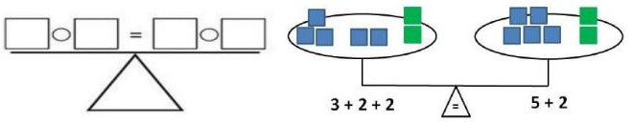
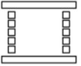

The Importance of Vocabulary
Our mathematics curriculum places great emphasis on the importance of pupils using the correct mathematical language as a central part of their learning. Pupils will be unable to articulate their mathematical reasoning if they lack the mathematical vocabulary required to do so. It is therefore essential that the teaching of strategies outlined in this policy is accompanied by the use of appropriate mathematical vocabulary, as set out in our curriculum documentation.
New vocabulary should be introduced in a suitable context (for example, with relevant real objects, apparatus, pictures or diagrams) and explained carefully. High expectations of the mathematical language used are essential, with all staff modelling vocabulary and only accepting what is correct. For example:

☑ | ☒
ones | units
is equal to | is
zero (0) | oh (the letter O)
number sentence /  calculation | sum

Addition and Subtraction

Glossary
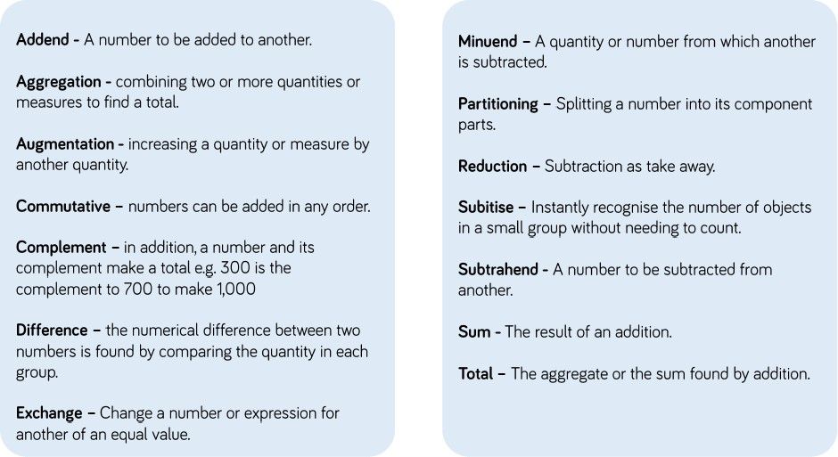

Addition

Pre-school | Guidance
Pre-school | Before addition can be introduced, pupils need to have a secure knowledge of number. In pre-school, pupils are introduced to the concept of counting, number order and number recognition through practical activities, games and child-initiated play.  Pupils also learn how to count 1-1 (pointing to each object as they count); they learn that anything can be counted, for example, claps, pupils and jumps. This is reinforced by opportunities for pupils to count in the outside provision, e.g. building blocks, lines on the floor, twigs etc.

Reception | Small Step | Guidance | Concrete | Pictorial | Abstract
Reception | Counting and adding more | Pupils are introduced to the concept of addition through practical games and activities. They act out addition by physically combining two groups of objects together.  Pupils learn to link counting on with adding more than one. | Pupils add one more child, object, cube or counter to a group to find one more.  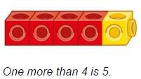  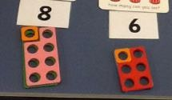 | Following modelling, pupils use a number line to support their understanding of adding one more by counting on.  6 + 1 =  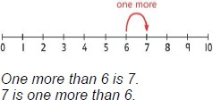  5 + 3 =  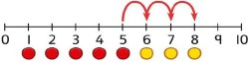 | Adults support pupils in recording their addition sums in written form.  3 + 2 = 5  ‘3 add 2 equals 5. We have got 5 altogether.’

Reception | Small Step | Guidance | Concrete | Pictorial | Abstract
Reception | Understanding part - part - whole relationships | Pupils sort and split groups using modelled stem stences to develop their understanding of parts and wholes. | Pupils sort children and objects in to groups; they understand that these are parts and that together they make the whole.  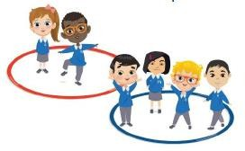  ‘The groups of children are 2 and  4. The parts are 2 and 4. There are 6 children.  The whole is 6.’ | Pupils draw to represent the parts and understand the relationship with the whole.  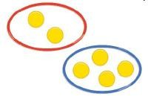  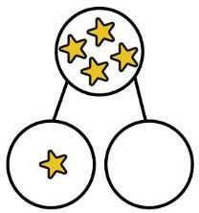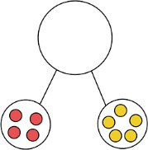 | Pupils use partially completed part-whole models to represent the numbers.  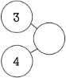

 | Small Step | Guidance | Concrete | Pictorial | Abstract
Year One | Combine two parts to make a whole | When adding numbers to 10, pupils can explore both aggregation and augmentation.  Part- whole models, bar charts, number shapes and tens frames support aggregation.  Tens frames, bead strings and number tracks support augmentation. | Pupils use a range of concrete resources to combine two parts.    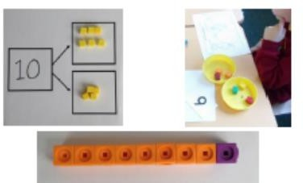  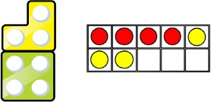 | Pupils represent cubes and counters using dots or crosses.  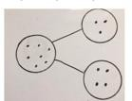  Pupils add these to part whole models.  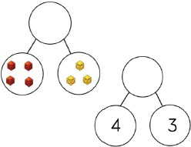  Number lines support counting on.  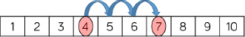 | 4 + 3 = 7  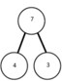  “Four is a part, 3 is a part and the whole is seven.”  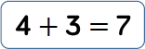  4 add 3 is equal to 7.

 | Small Step | Guidance | Concrete | Pictorial | Abstract
Year One | Start at the bigger number and count on, using cubes, Numicon and counters | Counting on from the biggest number is an opportunity to introduce the commutativity of addition. | Pupils count on using cubes and cups.  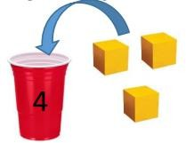  They count on using fingers and tens frames with counters.  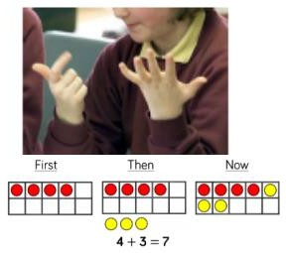  Pupils count on using a number line with cubes or Numicon.  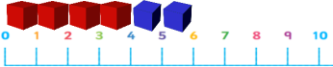  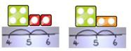 | Pupils draw representations of the manipulatives that they have used.  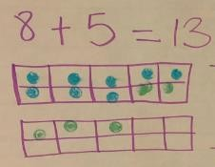  ‘5 more than 12 is equal to 17.’  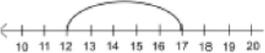  Pupils use a bar model which encourages them to count on, rather than count all.  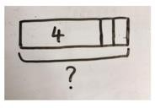  4 + 2 = 6 | Pupils make jottings of mental methods and show informal strategies.  A number line:  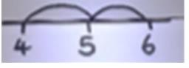  What is 2 more than 4? What is the sum of 4 and 2? What is the total of 2 and 4?  Commutative law:  4 + 2 = 6; 2 + 4 = 6  Mental method:  Put the largest number in your head and count on.

 | Small Step | Guidance | Concrete | Pictorial | Abstract
Year Two | Add by making 10 | When adding one digit numbers that cross 10, it is important to highlight the importance of ten ones equalling one ten.  Use concrete resources alongside number lines to support pupils in understanding how to partition their jumps. | Pupils regroup to make 10, using tens frames and counters/cubes, using Numicon or using straws.  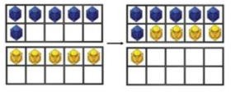  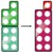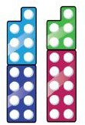  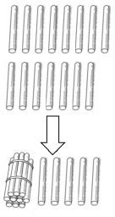 | Pupils draw tens frames and counters.  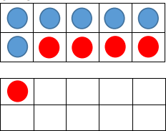  ‘6 + 5 is the same as 10 + 1.’  ‘I know that 6 + 4 = 10, and 1 more gives a total of 11.’  Pupils use a number line to add by making 10.  8 + 7 = □  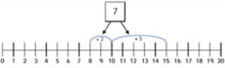  8 + 2 = 10  10 + 5 = 15  8 + 7 = 15 | Pupils develop an understanding of equality.  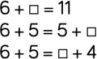  ‘7 can be partitioned in to 2 and 5. I know that 8 and 2 make 10, and I can then add the remaining 5 to make 15.’  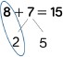

 | Small Step | Guidance | Concrete | Pictorial | Abstract
Year Two | Adding three single digits, crossing 10 | When adding one-digit numbers that cross 10, it is important to highlight the importance of ten ones equalling ten. | Pupils add three single digits using Numicon or counters on tens frames.  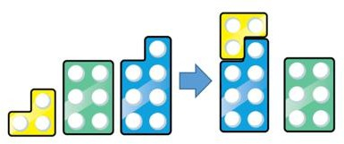  Pupils add three 1 digit numbers using dienes.  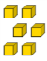      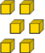  + + = | Pupils draw tens frames and counters.  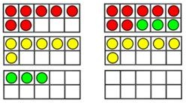  Pupils draw dienes to show exchanging.  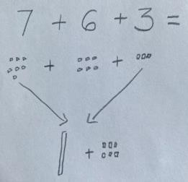  Pupils complete part-whole models with up to three parts.  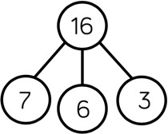 | Pupils reason about their strategy.  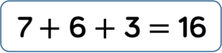  7 + 3 = 10  10 + 6 = 16

 | Small Step | Guidance | Concrete | Pictorial | Abstract
Year Two | Add 1 digit and 2 digit numbers to 100 | When adding single digits to a two-digit number, pupils should be encouraged to count on from the larger number.  They should apply their knowledge of number bonds to show efficiency.  Hundred squares and straws can support. | Pupils continue to develop an understanding of partitioning and place value.  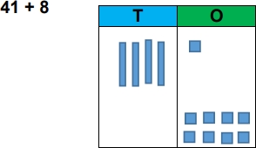  38 + 5  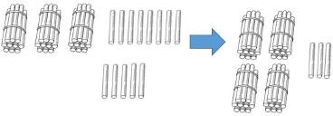 | Pupils represent dienes/base ten,  e.g. lines for tens, dots or crosses for ones.  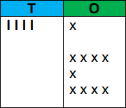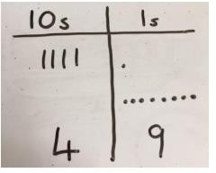  Pupils use blank number lines to count on from the larger number.  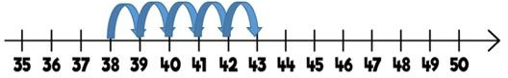  Pupils apply their knowledge of bonds.  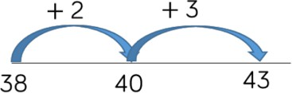  They apply their thinking to bar models and part-whole models.  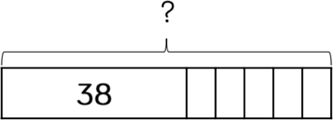  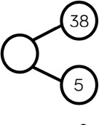 | Pupils make jottings to show how they have partitioned.  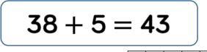  ‘38 + 2 = 40  40 + 3 = 43’  Mental method:  ‘41 + 8 is the same as 40 + 9.’

 | Small Step | Guidance | Concrete | Pictorial | Abstract
Year Two | Add two 2- | Encourage pupils | Continue to group manipulatives, | Pupils use a blank number line, jumping multiples of ten.  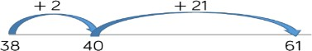  Pupils represent dienes/base ten and demonstrate that they have an understanding of adding the ones together first, then the tens.  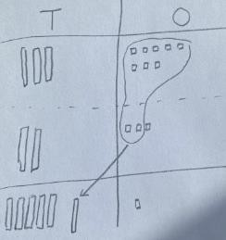  Pupils apply their understanding to part-whole and bar models.  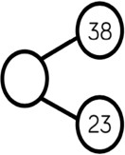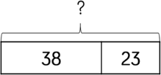 | Pupils make jottings to show how they have used an expanded method.  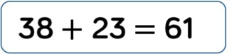  38 + 23 =  38 + 23  30 + 8 20 + 3  30 + 20 = 50  8 + 3 = 11  50 + 11 = 61
Year Two | digit numbers, | to count on using | counting on from the largest
Year Two | to 100 | manipulatives. This | number and using knowledge of
Year Two |  | may bridge the | bonds.
Year Two |  | tens boundary.
Year Two |  |  | 38 + 23
Year Two |  | Pupils may  exchange using manipulatives but do not need record | 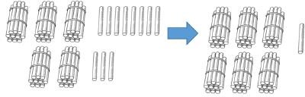
Year Two |  | this in a formal
Year Two |  | method. | Pupils demonstrate an
Year Two |  |  | understanding of exchanging,
Year Two |  | Encourage them to | when the tens boundary is
Year Two |  | jump to multiples | bridged.
Year Two |  | of 10 to become  more efficient. | 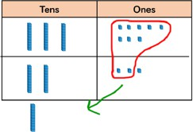

 | Small Step | Guidance | Concrete | Pictorial | Abstract
Year Three | Add numbers with up to 3 digits, including using column method with exchanging. | Base 10 and place value counters are the most effective manipulatives when adding numbers with up to 3 digits.  Encourage pupils to use the formal column method when calculating alongside straws, base 10 or place value counters.  As numbers become larger, straws become less efficient.  Pupils will use these methods to check subtraction answers. | Pupils are familiar using a place value grid with manipulatives.  265 + 164  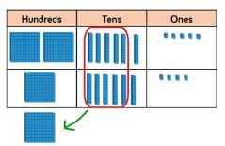  Pupils are confident with regrouping and exchanging.  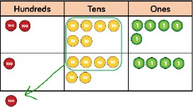 | Pupils draw a pictorial representation of the columns and place value counters, circling when they make an exchange.  243 + 368  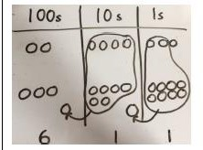  Pupils apply their understanding to a range of models.  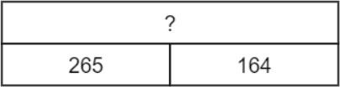  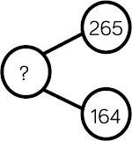 |   Pupils confidently use the formal column method, always starting with the ones column and exchanging when needed.  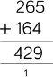  243 + 368 =  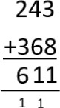

 | Small Step | Guidance | Concrete | Pictorial | Abstract
Year Three | Add fractions with the same denominator, up to 1 whole | Pupils practise adding fractions with the same denominator through a variety of increasingly complex problems to improve fluency. | Pupils partition shapes and objects in to equal parts.  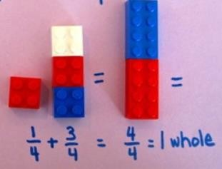  Pupils use concrete fraction circles/tiles or fraction walls to calculate the total amount of parts.  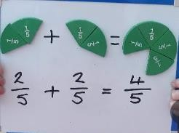 | Pupils draw and explore images and models which support adding parts of a whole. Drawing objects can give context to the fractions.  𝟓 𝟏  +  𝟕 𝟕  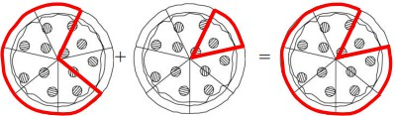  𝟏 𝟐  +  𝟓 𝟓    𝟑 𝟐  +  𝟕 𝟕  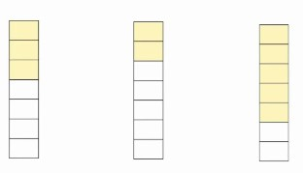 | 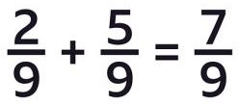  Two parts out of nine and five parts out of nine make a total of seven parts out of nine.

 | Small Step | Guidance | Concrete | Pictorial | Abstract
Year Four | Add numbers with up to 4 digits | Base 10 and place value counters are the most effective manipulatives when adding numbers with up to 4 digits.  Ensure pupils write out their calculation alongside any concrete resources so they can see the links to the written column method.  Plain counters on a place value grid can also be used to support learning.  Pupils will use these methods to check subtraction answers. | Pupils continue to use dienes or place value counters to add, exchanging 10 ones for a ten, 10 tens for a hundred and 10 hundreds for a thousand.  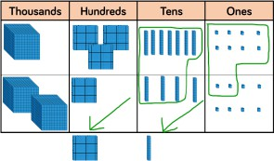  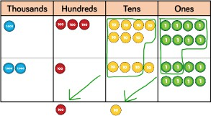 | Pupils draw representations using a place value grid and other models.  2634 + 4517  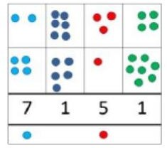  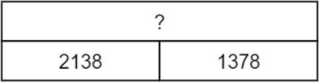  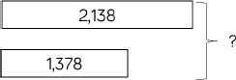  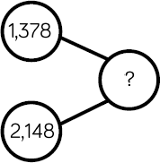 | 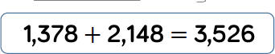  Pupils will add numbers with up to 4-digits using the formal written method of column addition.  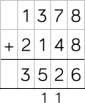  As the pupils become more secure, introduce decimals. Money can be used for context.  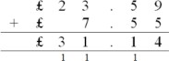

 | Small Step | Guidance | Concrete | Pictorial | Abstract
Year Four | Add fractions with the same denominator, including to total more than one whole | Pupils continue to add fractions with the same denominator, understanding that these can total more than one whole (improper fractions).  Pupils convert improper fractions in to mixed numbers. | Pupils use concrete resources to work out the total number of parts. Parts are regrouped to show wholes and parts.  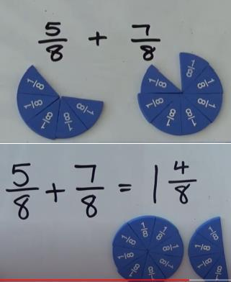 | Pupils become familiar when working with images that represent fractions.  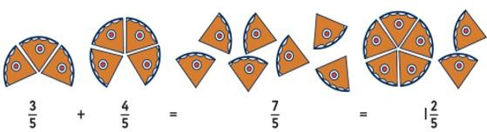  Bar models/number frames are used to show parts and wholes.  5 6  +    8 8  3 6  +  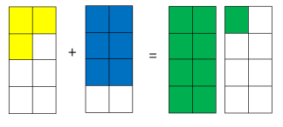  8 8  Pupils count up in fraction amounts using a number line.  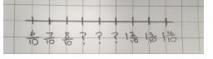 | 5 6 11 3  + = = 1  8 8 8 8  Five parts out of eight and six parts out of eight, total eleven parts out of eight.  Eleven parts out of eight is the same as one whole and three parts out of eight.

 | Small Step | Guidance | Concrete | Pictorial | Abstract
Year Five | Add numbers with more than 4 digits  This small step is consolidated in Year 6. | Pupils should be encouraged to work in the abstract, using the column method to add larger numbers.  Pupils will use rounding to estimate answers before solving calculations. | Place value counters or plain counters on a place value grid are the most effective concrete resources to support adding numbers with more than 4 digits.  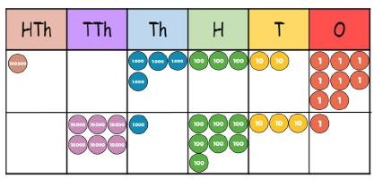 | Pupils develop reasoning skills by using a range of representations including part whole models, number sentences, place value counter problems and bar models.  Pupils can, if they need to, draw their own representations, using place value charts.  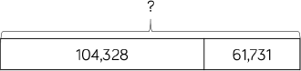  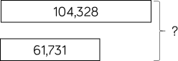  Pupils draw an empty number line and use it to count on.  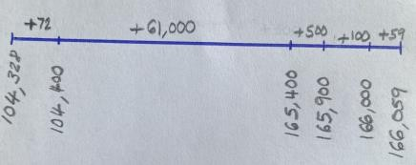 |   Pupils use formal column addition for numbers with more than 4 digits.  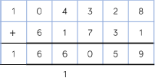

 | Small Step | Guidance | Concrete | Pictorial | Abstract
Year Five | Add numbers with up 3 decimal places  This small step is consolidated in Year 6. | Place value counters and plain counters on a place value grid are the most effective manipulatives when adding decimals with 1, 2  and 3 decimal places.  Ensure pupils have experience of adding decimals with a variety of decimal places. This includes putting this into context when adding money and other measures. | Pupils begin to use decimal place value counters.  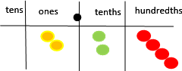  Pupils demonstrate exchanging, when adding.  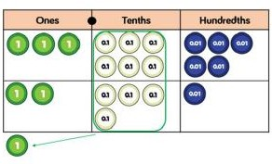  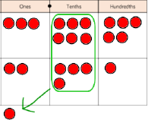 | Pupils draw a range of representations, including using a place value grid, bar models and part whole models.  2.37 + 81.79 =  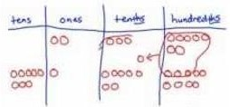  3.65 + 2.41 =  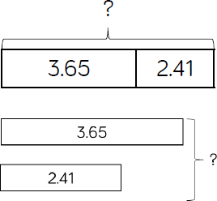  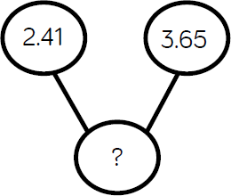 | 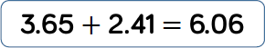  Pupils use formal column addition.  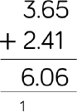  Money can be used to provide pupils with context.  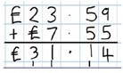

 | Small Step | Guidance | Concrete | Pictorial | Abstract
Year Five | Add fractions with denominators that are multiples of the same number | Pupils use their knowledge of times tables to find common multiples.  Pupils know that common denominators are numbers that both denominators will divide into evenly. | Pupils use paper strips to create fractions where one denominator is a multiple of the other. They convert one denominator into the other by splitting the fraction, so the denominators are equal.  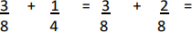  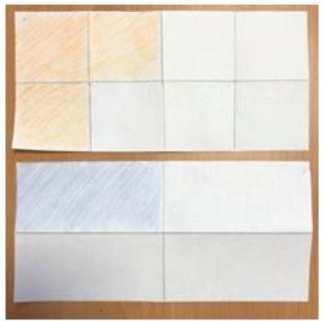 | Pupils use a bar model to add fractions with demoninators that are common multiples.  2 5  + =  5 10  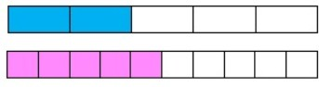  Pupils see that one fifth is the same as two tenths.  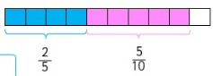  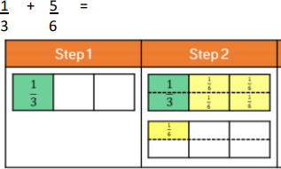 | Pupils convert numbers with different denominators, so that they have the same (or common) denominator.  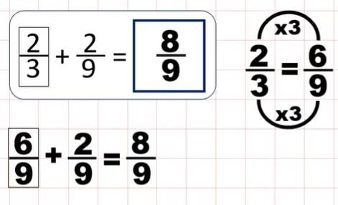

 | Small Step | Guidance | Concrete | Pictorial | Abstract
Year Five | Add mixed numbers | Pupils use a range of strategies to add mixed numbers. | Pupils use Numicon to support their understanding of mixed numbers.  When using numicon, the base piece represents the denominator and the top pieces, or pegs, represent the numerator.  1 3  1 + 1 =  5 6  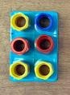  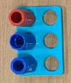  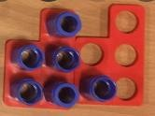 + | Pupils represent mixed numbers using drawings and bar models.  3 5  2 + 2 =  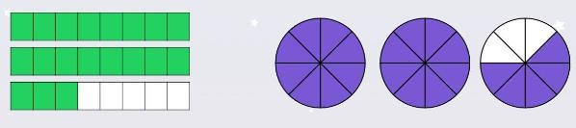  8 8  +  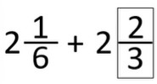  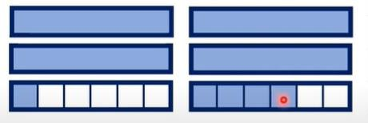 | Pupils convert mixed numbers to improper fractions, then add them together.  Pupils also add the whole numbers together first, then add the fractions together, using skills from the small step prior.  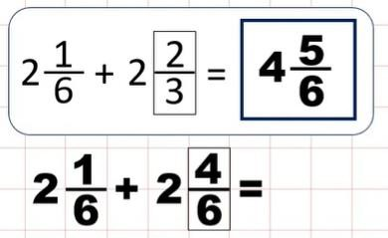

 | Small Step | Guidance | Concrete | Pictorial | Abstract
Year Six | Add several numbers of increasing complexity | Pupils add a range of numbers up to ten million, including adding money, measures, and decimals, with different numbers of decimal places. | Pupils select appropriate manipulatives, when necessary. | Pupils draw a range of representations to support reasoning responses. | Pupils identify that they only need to use formal column addition for numbers that cannot be added mentally.  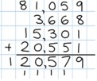  When adding decimals, pupils automatically insert zeros for place holders.  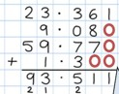

 | Small Step | Guidance | Concrete | Pictorial | Abstract
Year Six | Use equivalent fractions to add numbers with different denominators | Pupils add fractions with different denominators and add mixed numbers, using the concept of equivalent fractions.  Pupils are encouraged to find the least common denominator (the smallest multiples that the denominators have in common). | Pupils select appropriate manipulatives, when necessary. | Pupils use a range of representations, including bar models.  1 1  1 + =  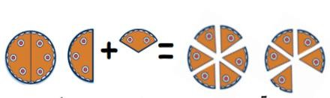  2 3  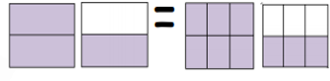  2 5 7  + + =  3 6 12  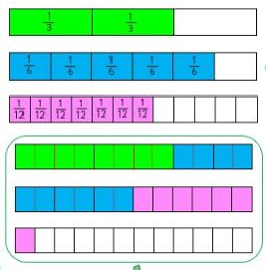 | Pupils are encouraged to revert to expanded methods if they experience any difficulty.  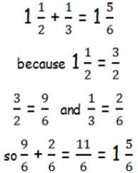

Subtraction

Pre-school | Guidance
Pre-school | Before subtraction can be introduced, pupils need to have a secure knowledge of number. In pre-school, pupils are introduced to the concept of counting backwards through child-initiated games such as acting out counting songs and running races, e.g. pupils shouting “5,4,3,2,1,0 - GO!”.

 | Small Step | Guidance | Concrete | Pictorial | Abstract
Reception | Physically take away objects from a whole | Pupils build on their previous knowledge by learning that subtracting means taking away a certain number of objects from a group (leaving them with fewer objects).  Use part-whole models, bar models, ten frames and number shapes to support partitioning. | Pupils arrange objects and remove some to find how many are left.  4 – 3 =  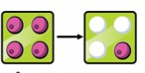  6 – 1 =  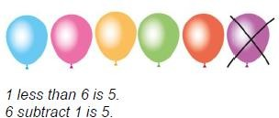 | Pupils match images and drawings that are the same as their subtraction number sentence/story.  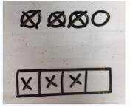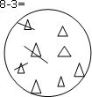  Pupils say one less using a number track to support their counting. | Adults support pupils in recording their subtractions in written form.  5 – 3 = 2  ‘5 take away 3 equals 2. We have  got 2 left.’

 | Small Step | Guidance | Concrete | Pictorial | Abstract
Year One | Counting back | Pupils use ten frames, number tracks, single bar models and bead strings for support. | Pupils use bead strings to count back, counting backwards in ones as they move the beads along.  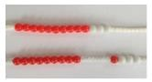  Pupils use counters or cubes and move them away from the group, counting backwards as each one is moved away.  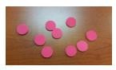 | Pupils count back using number lines or number tracks.  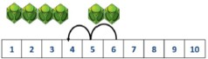  Pupils represent what they see using drawings.  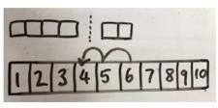 | 6 – 2 = 4

 | Small Step | Guidance | Concrete | Pictorial | Abstract
Year One | Finding the difference | Pupils use cubes and bar models with two bars to support finding the difference.  Pupils show this understanding using bar models and part-whole models. | Finding the difference, using cubes, Numicon or Cuisenaire rods, as well as other objects.  Calculate the difference between 8 and 5:  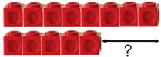  Pupils use the part-whole model to help explain the inverse relationship between addition and subtraction.  10 – 6 =  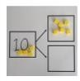 | Pupils draw the concrete objects, which they have used.  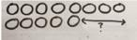  Pupils use a bar model to illustrate what they need to calculate.  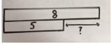  Pupils draw objects within a part-whole model.  6 – 2 =  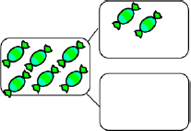 | Pupil transfer their understanding to missing box problems and reasoning questions.  8 – 5 =  The difference is □  9 – 6 =  8 – 5 =  7 – 4 =  Why do these calculations have the same difference?  Pupils move to using numbers within a part-whole model.  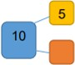

 | Small Step | Guidance | Concrete | Pictorial | Abstract
Year Two | Subtract numbers up to 20 by making  10 | Pupils should be encouraged to find the number bond to 10 when partitioning the subtracted number.  Ten frames, number shapes and number lines are particularly useful to support this. | Pupils demonstrate their understanding using a range of manipulatives and concrete supports.  14 – 6 =  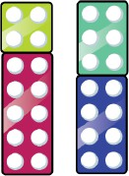  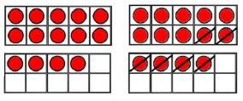  Pupils demonstrate exchanging a bundle of ten straws for ten individual straws.  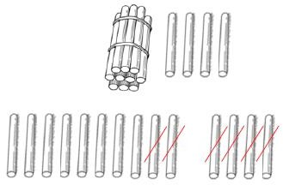  Pupils physically move counters on a number track to count back.  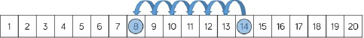 | Part-whole models, bar models and number lines support pupils understanding of subtraction.  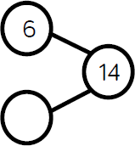  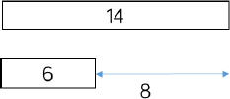  Pupils show their understanding of partitioning using a number line.  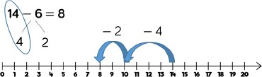 | Pupils demonstrate the mental strategy of partitioning using heir knowledge of number bonds.  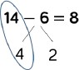  ‘14 – 6 is the same as 14 – 4 – 2.  14 – 4 = 10  10 – 2 = 8’  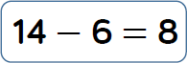

 | Small Step | Guidance | Concrete | Pictorial | Abstract
Year Two | Use place value to subtract without exchanges | Pupils use manipulatives (such as straws, base 10 or place value counters) to calculate subtraction. | Pupils use base ten on a place value chart. They do not have to exchange tens for ones.  34 – 13 =  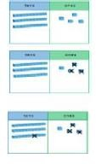 | Pupils move on to using jottings and they represent the base ten pictorially.  43 – 21 =    Where appropriate, pupils use number lines to count back in multiples.  75 – 30 =  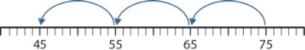  ‘75 – 30 is the same as 75 – 10 – 10 –  10.’ | 43 – 21 = 22

 | Small Step | Guidance | Concrete | Pictorial | Abstract
Year Two | Use place value to subtract while crossing the 10 (exchange) | Progression in this step sees pupils crossing one ten before crossing more than one ten.  Pupils use a blank number line to count back to find the difference.  Encourage them to jump to multiples of 10 to become more efficient.  Pupils develop an understanding that, once exchanged, there are more than ten ones in the ones column on a place value grid. | Pupils use base 10 to support and model physical exchanges.  65 – 25 =  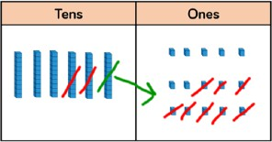  Pupils use a bead string to count on to the next ten and then the rest.  34 – 28 =  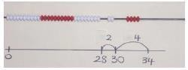  ‘The difference between 28 and 30 is  2. The difference between 30 and 34 is 4. The total difference is 6.’ | Pupils represent base ten pictorially, remembering to show the exchange.  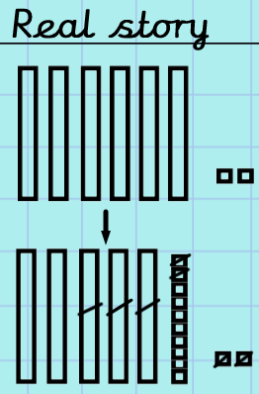  Pupils use a number line to count on to the next ten and then the rest.  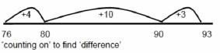 | Pupils start to record subtraction using expanded methods.  65 – 38 =  15 – 8 = 7  50 – 30 = 20  65 – 38 = 27

 | Small Step | Guidance | Concrete | Pictorial | Abstract
Year Three | Use column method up to 3 digits, with exchanges | Pupils will first be introduced to the formal column method without exchanges.  Pupils are encouraged to use the formal column method when calculating, alongside straws, base 10 or place value counters. As numbers become larger, straws become less efficient.  Pupils will use these methods to check addition answers. | Pupils use manipulatives within a H, T, O place value grid.  Manipulatives are exchanged where needed and removed from the grid as they are subtracted.  435 - 273 =  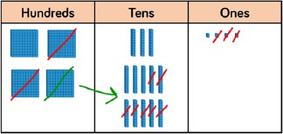  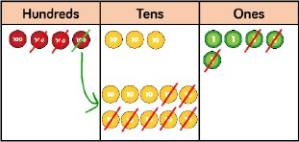  Plain counters on a place value grid can also be used to support learning. | Jottings and informal methods support pupils’ mental calculations. Pupils represent manipulatives pictorially, showing what has been exchanged.  234 – 88 =  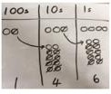  Pupils use an empty number line to count back and to count on to find the difference.  297 – 126 =  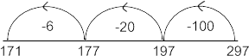  84 – 56 =  +4 +20 +4  56 60 80 84  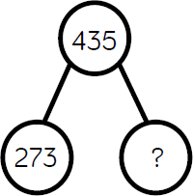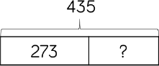 | Pupils begin by partitioning into the place value columns.  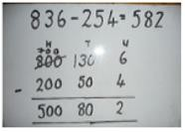  Pupils write out their calculation alongside any concrete resources so that they can see the links to the written column method.  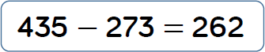  Pupils show an understanding of what has happened when they have crossed out digits.  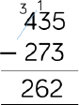

 | Small Step | Guidance | Concrete | Pictorial | Abstract
Year Three | Subtract fractions with the same denominator up to 1 whole | Pupils practise subtracting fractions with the same denominator through a variety of increasingly complex problems to improve fluency. | Pupils partition shapes and objects into equal parts.  Pupils use concrete fraction circles/tiles or fraction walls to calculate the total amount of parts.  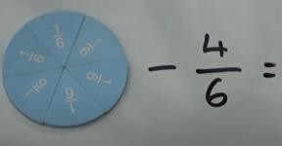  Unifix cubes or fraction equivalency cubes can be used.  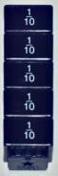 – 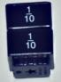 = 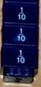 | Pupils draw and explore images and models which support subtracting parts of a whole.  Drawing objects can give context to the fractions.    Pupils subtract by crossing out on labelled and unlabelled fraction strips.  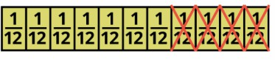   | Colours may be used to prompt the pupils to only subtract the numerators.  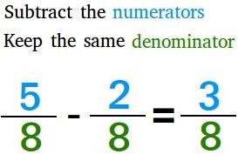  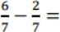  Six parts out of seven take away two parts out of seven leaves four parts out of seven.

 | Small Step | Guidance | Concrete | Pictorial | Abstract
Year Four | Subtract numbers with up to 4 digits including exchanges | Base 10 and place value counters are the most effective manipulatives when subtracting numbers with up to 4 digits.  Pupils write out their calculation alongside any concrete resources so that they can see the links to the written column method. | Pupils continue to use manipulatives and place value grids to support learning.  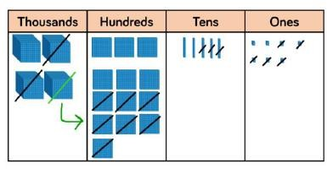  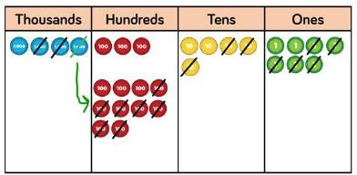  Plain counters on a place value grid can also be used. | Pupils to draw manipulatives and show their exchange. This can then be transferred to a range of representations.  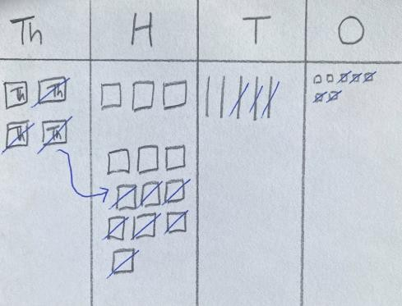  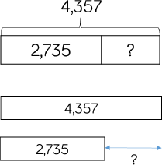  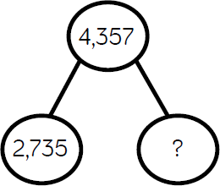 | Pupils demonstrate a number of exchanges.  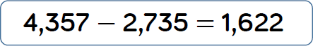  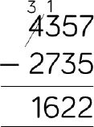  Decimal subtraction can be introduced through the context of money.  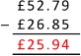

 | Small Step | Guidance | Concrete | Pictorial | Abstract
Year Four | Subtract fractions with the same denominator, including numbers more than one whole | Pupils subtract fractions and numbers that can total more than one whole (improper fractions), continuing to work with numbers with the same denominator.  Pupils convert improper fractions in to mixed numbers. | Pupils use concrete resources to work out the total number of parts. Parts are regrouped to show wholes and parts.  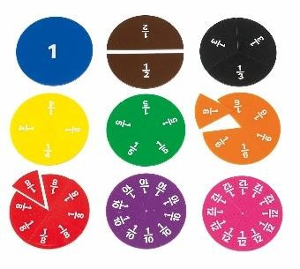 | Pupils become familiar when working with images that represent fractions.  3 2  2 – 1 =  4 4  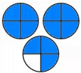 – 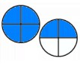 = 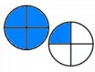  Bar models/number frames are used to show parts and wholes.  10 4  – =  5 5  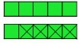  Pupils count back in fraction amounts using a number line. | 3 11  1 =  8 8  11 6 5  – =  8 8 8  One whole and three parts out of eight is the same as eleven parts out of eight.  Eleven parts out of eight take away six parts out of eight, leaves five parts out of eight.

 | Small Step | Guidance | Concrete | Pictorial | Abstract
Year Five | Subtract numbers with more than 4 digits  This small step is consolidated in Year 6. | Pupils should be choosing the most efficient strategies to solve subtraction calculations.  Pupils will use rounding to estimate answers before solving calculations. | Place value counters or plain counters on a place value grid are the most effective concrete resource when subtracting numbers with more than 4 digits.  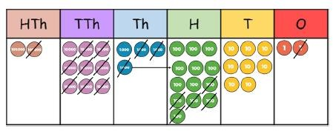 | Pupils develop reasoning skills by using a range of representations including part whole models, number sentences, place value counter problems and bar models.  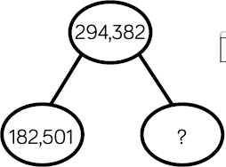  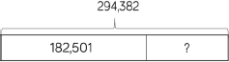  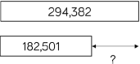  Pupils can, if they need to, draw their own representations, using place value charts. | Pupils should be encouraged to work in the abstract, using coloumn method to subtract larger number efficiently.  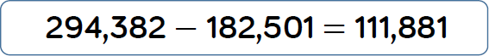  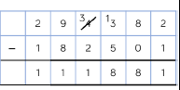  Pupils subtract large numbers and decimals. They show an understanding of where place holders are required.  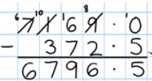

 | Small Step | Guidance | Concrete | Pictorial | Abstract
Year Five | Subtract numbers with up to 3 decimal places  This small step is consolidated in Year 6. | Pupils have experience of subtracting decimals with a variety of decimal places. This includes subtracting money and other measures.  Pupils subtract with decimal values, including mixtures of integers and decimals, ensuring they align the decimal. | Place value decimal counters and plain counters on a place value grid are the most effective manipulative when subtracting decimals with 1, 2 and then 3 decimal places.  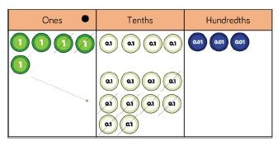  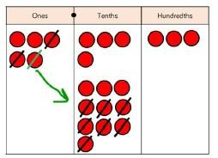 | Pupils draw a range of representations, including using a place value grid, bar models and part whole models.  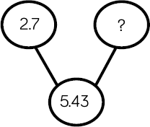  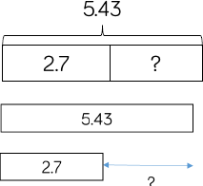 | Pupils use formal column subtraction. Money can be used to provide pupils with context.  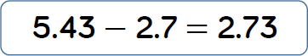  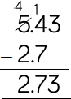

 | Small Step | Guidance | Concrete | Pictorial | Abstract
Year Five | Subtract fractions with denominators that are multiples of the same number | Pupils use their knowledge of times tables to find common multiples.  Pupils know that common denominators are numbers that both denominators will divide into evenly. | Pupils use paper strips to create fractions where one denominator is a multiple of the other. They convert one denominator into the other by splitting (folding) the fraction, so the denominators are equal.  3 2  – =  4 8  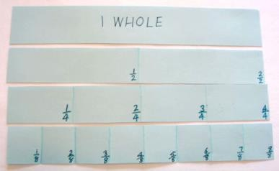 | Pupils use a bar model to subtract fractions with demoninators that are common multiples.  3 2  – =  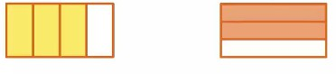  4 3  –  11 1  – =  12 3  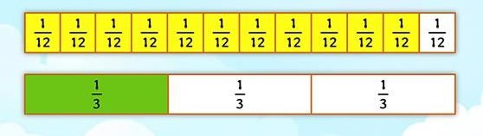 | Pupils convert numbers with different denominators, so that they have the same (or common) denominator.  2 1  – =  3 6

 | Small Step | Guidance | Concrete | Pictorial | Abstract
Year Five | Subtract mixed numbers | Pupils use a range of strategies to subtract mixed numbers. | Pupils use Numicon to support their understanding of mixed numbers.  When using numicon, the base piece represents the denominator and the top pieces, or pegs, represent the numerator.  𝟑 𝟏  1 – 1 =  𝟔 𝟓 | Pupils represent mixed numbers using drawings and bar models.  5  There are 4 pizzas.  6  1  Abbey eats 2 pizzas.  3  How much pizza is left?  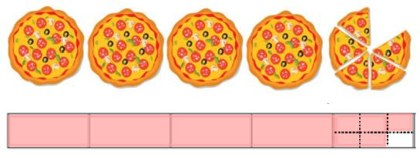  𝟏 𝟑  2 – 1 =  𝟒 𝟓  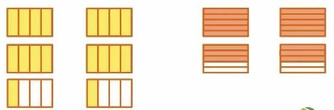 | Pupils convert mixed numbers to improper fractions, then calculate the difference.  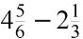

 | Small Step | Guidance | Concrete | Pictorial | Abstract
Year Six | Subtract increasingly large and more complex numbers and decimal values | Pupils subtract a range of numbers up to ten million, including adding money, measures, and decimals, with different numbers of decimal places. | Pupils select appropriate manipulatives, when necessary. | Pupils draw a range of representations to support reasoning responses. | Pupils identify that they only need to use formal column subtraction for numbers that cannot be added mentally.  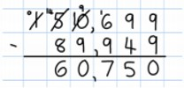  When subtracting decimals, pupils automatically insert zeros for place holders.  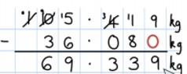

 | Small Step | Guidance | Concrete | Pictorial | Abstract
Year Six | Use equivalent fractions to subtract numbers with different denominators | Pupils add fractions with different denominators and add mixed numbers, using the concept of equivalent fractions.  Pupils are encouraged to find the least common denominator (the smallest multiples that the denominators have in common). | Pupils select appropriate manipulatives, when necessary. | Pupils use a range of representations, including bar models.  5 1 2  – – =  6 3 12  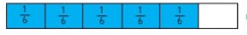  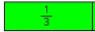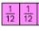 | Pupils are encouraged to revert to expanded methods if they experience any difficulty.  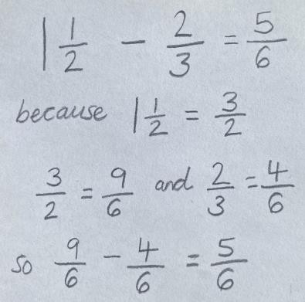  Pupils simplify fractions where needed.

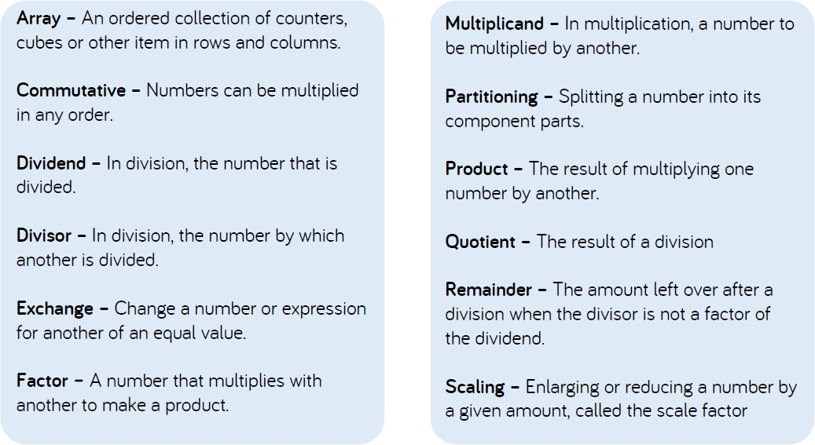
Multiplication and Division Glossary

Multiplication

Pre-school | Guidance
Pre-school | Pupils are introduced to the concept of doubling through practical games and activities, including the use of mirrors, to explore the concept that two objects or groups are the same. Matching activities can help teach visual discrimination, which is important as pupils learn to read letters and numbers.

 | Small Step | Guidance | Concrete | Pictorial | Abstract
Reception | Double numbers and quantities of objects up to 5+5 | Pupils are expected to understand the concept of doubling and to be able to double a number up to 10.  Before doubling can be introduced, children need to have a secure knowledge of counting, number facts and addition in order to double.  Pupils explore odd and even numbers, whilst doubling. | Pupils carry out practical activities using manipulatives, such as cubes and Numicon, to demonstrate doubling.  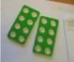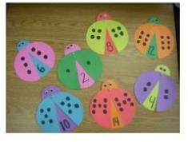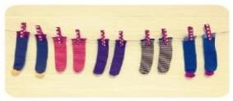  Pupils act out doubling by physically combining two equal groups.  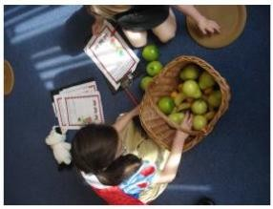 | Pupils use known representations to draw the ‘mirrored’ amount of a number.    Pupils draw representations of the objects they have used.  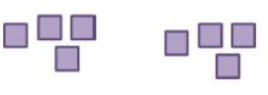  Pupils transfer their understanding of doubles to part-whole models.  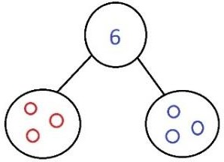 | With support, pupils complete rehearsed sentence stems.  Double 4 is . 4 and 4 makes .

 | Small Step | Guidance | Concrete | Pictorial | Abstract
Year One | Use arrays and repeated addition to solve 1-step multiplication problems | Pupils represent multiplication as repeated addition in many different ways.  Pupils use concrete and pictorial representation to solve problems.  They are not expected to record multiplication formally. | Pupils use objects laid out in arrays to find the answers to simple problems.  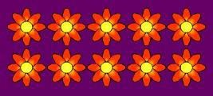  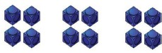  Pupils organise manipulatives to show repeated addition of equal groups.  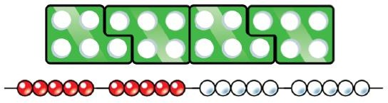 | Pupils represent the practical resources using drawings.    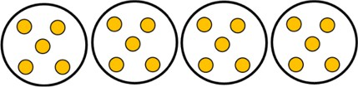  Pupils show their understanding of repeated addition on a bar model.  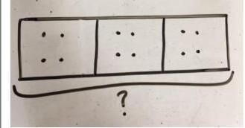 | Pupils represent repeated addition using the addition symbol.  ‘4 lots of 5 makes 20.’

 | Small Step | Guidance | Concrete | Pictorial | Abstract
Year One | Count in multiples (2, 5, 10) | Pupils count in multiples of 2, 5  and 10 aloud.  Pupils to jump in multiples of 2s, 5s and 10s along a structured number line or number track. | Pupils count the group as they are skip counting.  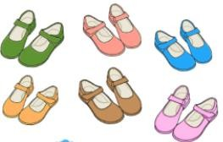  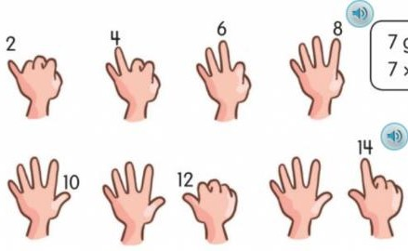    Pupils may use their fingers to help remember the groups they have counted. | Pupils draw representations to show counting in multiples.    Pupils show their skip counting on a structured number line or track.  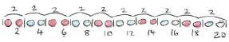  Pupils use a bar model to show multiples.  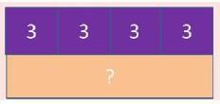 | Pupils write sequences with multiples of numbers.  2, 4, 6, 8, 10  5, 10, 15, 20, 25, 30

 | Small Step | Guidance | Concrete | Pictorial | Abstract
Year Two | Solve problems including repeated groups of multiples | Pupils are introduced to the multiplication symbol.  Pupils understand that multiplication is commutative. They understand that the order of the multiplication does not change the answer.  This should be taught alongside division so that pupils learn how the two operations work together. | Pupils use cuisenaire rods to solve problems involving repeated groups.  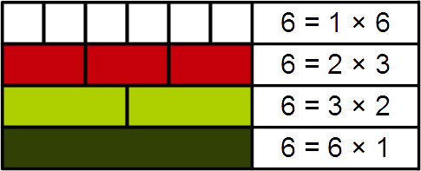  Pupils create arrays, using objects such as counters and cubes, to illustrate commutativity.  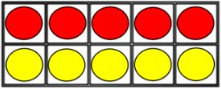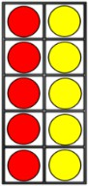  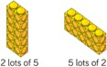 | Pupils use a number line to solve repeated groups of multiples.  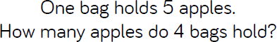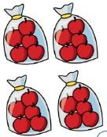  Pupils draw their own number lines.  4 x 3 =  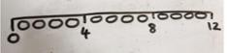  Pupils draw arrays to illustrate commutativity of multiplication facts.  2 x 5 =  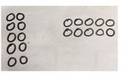 | Pupils use the multiplication symbol to represent a range of calculations that they have solved.  4 x 5 = 20  5 x 4 = 20  20 = 4 x 5  20 = 5 x 4

 | Small Step | Guidance | Concrete | Pictorial | Abstract
Year Two | Doubling numbers using partitioning | Pupils partition a number and then double each part before recombining it back together.  Pupils have an understanding that doubling means to multiply by two. | Pupils demonstrate doubling using dienes and place value counters to partition the number.  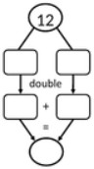  Double 12: | Pupils draw pictures and representations to demonstrate how to double numbers through partitioning.  Double 26:  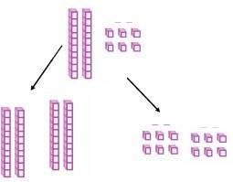 | Pupils use an expanded part-whole model to show how they have partitioned the number, before doubling each part.  They show how the parts are recombined, using addition.  Double 16:  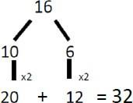

 | Small Step | Guidance | Concrete | Pictorial | Abstract
Year Three | Use informal methods to multiply a 2 digit number by a 1 digit number, with and without exchanges | Pupils use their knowledge of arrays when they are first introduced to the grid method.  Pupils use partitioning to support their construction of the grid method.  Pupils explore a range of manipulatives, encouraging them to work towards selecting a more efficient method of calculation. | Pupils make arrays using counters.  4 x 13 =  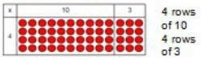  Pupils move on to base ten to move towards a more compact method.  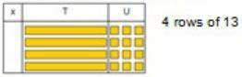  They then move on to place value counters to show finding groups of a number.  4 x 126 =  Pupils fill each row with counters.  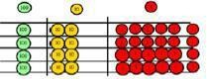  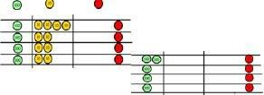    They then add up each column, starting with the ones, making any exchanges needed. | Pupils represent their work with place value counters in a way that they understand.  They can draw the counters using colour to show different amounts or draw circles in the different columns to show their thinking.  24 x 3 =  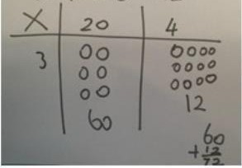  Pupils use bar models to explore missing numbers.  4 x □ = 20  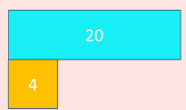 | Pupils multiply by one digit numbers, showing the clear addition alongside.  7 x 35 =  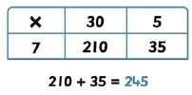  They use mental methods where appropriate.  ‘I know that 7 x 3 is 21, so  therefore 7 x 30 is 210.’

 | Small Step | Guidance | Concrete | Pictorial | Abstract
Year Three | Use formal written methods to multiply a 2 digit number by a 1 digit number, with no exchanges | Pupils explore the expanded method of multiplication by making the calculations concretely and then drawing them alongside a written method to aid understanding before moving on to short multiplication. | Pupils can continue to be supported by place value counters and base ten at this stage of multiplication. This is initially done where there is no  regrouping.  It is important at this stage that pupils always multiply the ones column first.  Pupils use a place value grid to demonstrate how numbers have been partitioned before multiplying each group.  23 x 3 =  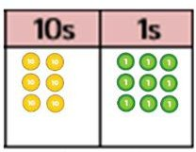  ‘3 lots of 20 is 60.  3 lots of 3 is 9.  6 tens and 9 ones is 69.’ | Pupils represent their use of manipulatives pictorially.  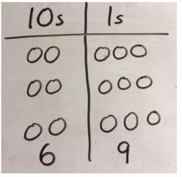  23 x 3 =  0 | Pupils record what it is they are doing in order to show their understanding of number composition.  Pupils move on to recording using the formal short multiplication columnar method.  23 x 3 =  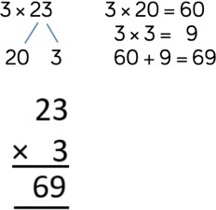

 | Small Step | Guidance | Concrete | Pictorial | Abstract
Year Three | Use formal written methods to multiply a 2 digit number by a 1 digit number, with exchanges | As before, pupils explore the expanded method of multiplication by making the calculations concretely and then drawing them alongside a written method to aid understanding before moving on to short multiplication.  Pupils explore and demonstrate their understanding of regrouping. | Pupils use base ten and place value counters to support their understanding of the method rather than supporting multiplication.  Pupils should use their times tables facts when solving multiplication.  34 x 5 =  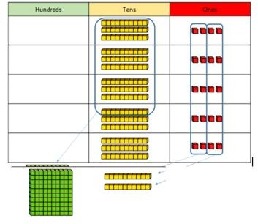  Pupils are able to explain any regrouping.  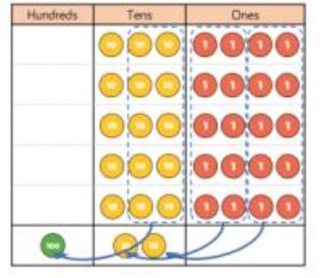 | Pupils draw the manipulatives that they are using, clearly showing exchanges.  34 x 5 =  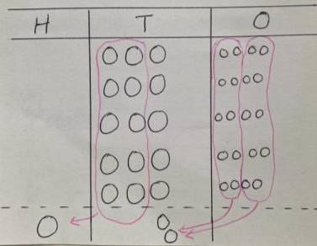  Bar modelling and number lines can support pupils when solving problems with multiplication alongside mental jottings and informal methods.  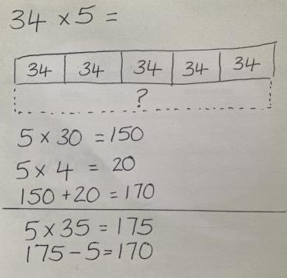 | Pupils initially use the grid method, before moving on to the expanded column method and the formal short multiplication column method.  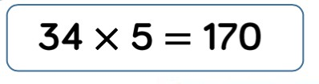  150 + 20 = 170  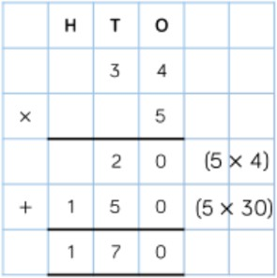  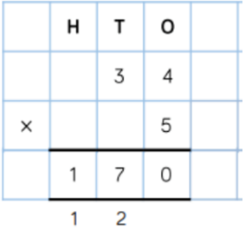
x | 30 | 4
5 | 150 | 20

 | Small Step | Guidance | Concrete | Pictorial | Abstract
Year Four | Use formal written methods to multiply a 3 digit number by a 1 digit number | When moving to 3 digit by 1 digit multiplication, pupils should be encouraged to use the formal written column method with efficiency.  As this is introduced, limit the number of exchanges needed in the questions and move pupils away from resources as they gain more confidence to work abstractly. | Pupils use base 10 and place value counters, where needed, to continue to support the understanding of the written method.  The corresponding formal method is modelled alongside there concrete materials.  245 x 4 =  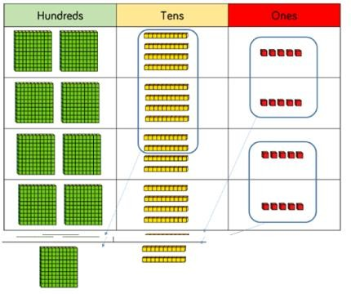  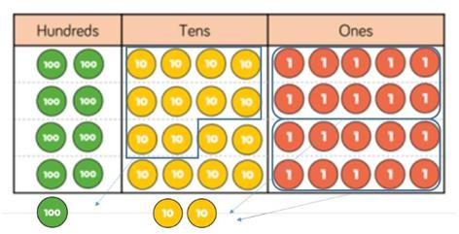 | Pupils represent their work with place value counters in a way that they understand.  They draw the counters using colour to show different amounts or draw circles in the different columns to show their thinking.  245 x 4 =  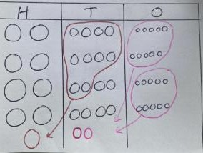  Pupils draw the grid method using base 10, where appropriate and necessary.  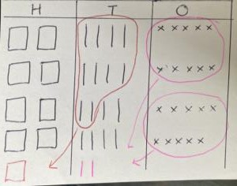 | Pupils demonstrate their understanding of multiplying 3 digit by 1 digit numbers using the grid method.  327 x 4 =  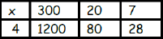  1200 + 80 + 28 = 1,308  Pupils transfer their understanding to the formal column written method, showing multiple exchanges.  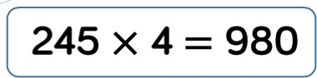  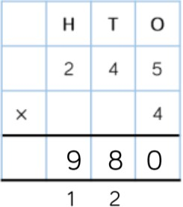

 | Small Step | Guidance | Concrete | Pictorial | Abstract
Year Five | Use formal written methods to multiply a 4 digit number by a 1 digit number | When multiplying 4-digit numbers, place value counters are the best manipulative to use to support pupils in their understanding of the formal written method.  If pupils are multiplying larger numbers and struggling with their times tables, encourage the use of multiplication grids so children can focus on the use of the written method. | Pupils can continue to be supported by place value counters at this stage of multiplication. This is initially done where there is no regrouping.  Manipulatives may still be used with the corresponding multiplication modelled alongside.  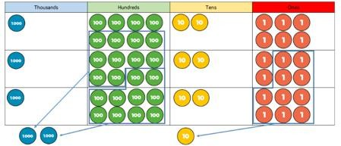 | Pupils can draw the grid method using base 10 and counters, where appropriate and necessary.  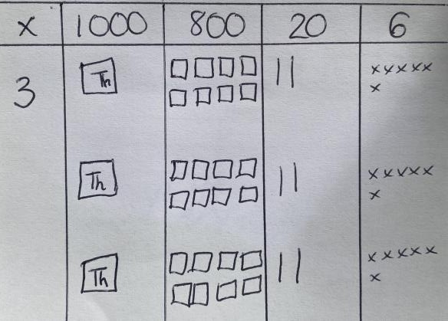 | Pupils understand that the formal written column method for multiplication is the most efficient method for multiplying 4 digit numbers.  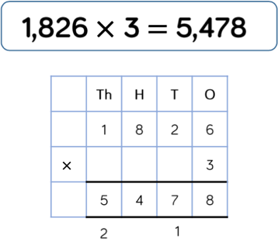

 | Small Step | Guidance | Concrete | Pictorial | Abstract
Year Five | Use formal written methods to multiply a 2 digit number by a 2 digit number | When multiplying a multi-digit number by two digits, pupils use the area model to understand the size of the numbers they are using. This links to finding the area of a rectangle by finding the space covered by the base 10.  The grid method matches the area model as an initial method to work concretely and then once then understand the process they should move to the formal written method. | Pupils partition both 2-digit numbers in to tens and ones. Base ten are used to show how many tens and ones are in each column or row.  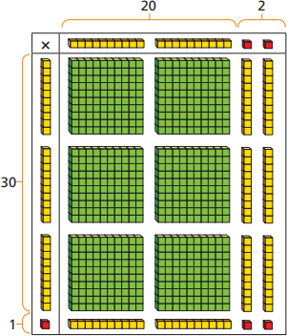  Pupils move to using place value counters to represent the numbers (reinforcing cardinality).  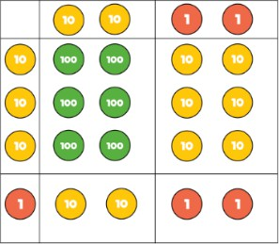 | Pupils draw a grid and the manipulatives within it, if required, before moving to the formal written method.  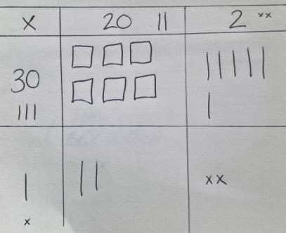 | Pupils continue to use the grid method to support problem solving.  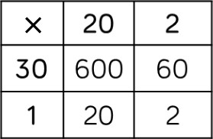  When completing the long multiplication method, pupils must remember the place holder, in the ones column, when multiplying the tens.    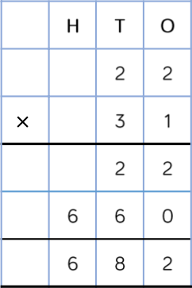

 | Small Step | Guidance | Concrete | Pictorial | Abstract
Year Five | Use formal written methods to multiply a 3-digit number by a 2-digit number | Pupils can continue to use the area model when multiplying a 3-digit number by a 2-digit number.  Encourage pupils to move towards the formal written method as the most efficient method for multiplication, seeing the links with the grid method. | Place value counters become the most efficient concrete resource for pupils to use, however base 10 can continue to be used to highlight the size of the numbers.  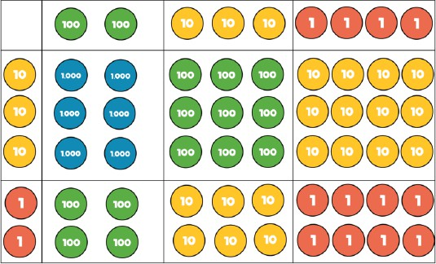  Pupils use formal and informal written methods and jottings, alongside the concrete, in order to record any addition that is required. | If needed, pupils draw a grid and the manipulatives within it before moving to the formal written method. | Where needed, pupils make jottings to record the total sum of the grid.  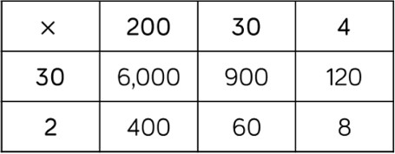  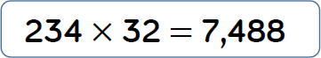  Pupils are confident in accurately recording multiple exchanges.  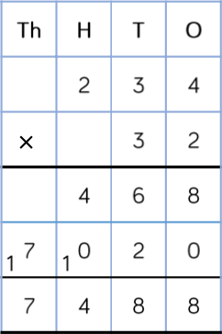

 | Small Step | Guidance | Concrete | Pictorial | Abstract
Year Five | Use formal written methods to multiply a 4-digit number by a 2-digit number  This small step is consolidated in Year 6. | When multiplying a 4-digit number by a 2-digit number, pupils should be confident in using the formal written column method.  If pupils are struggling with times tables, provide multiplication grids to support. This will allow pupils to reduce cognitive load and focus on how to use the method. | Pupils select appropriate manipulatives, when necessary. | Pupils draw a range of representations to support reasoning responses. | Pupils consider where exchanged digits are placed and make sure that this is consistent.  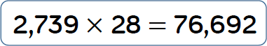  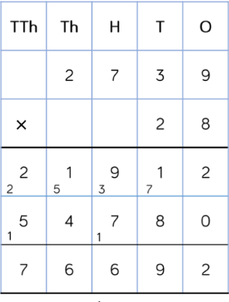  Pupils continue to use jottings to explain each calculation within their strategy.  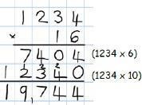

 | Small Step | Guidance | Concrete | Pictorial | Abstract
Year Five | Multiply proper fractions by whole numbers | When multiplying fractions by a whole integer, pupils will need to understand why it is only the numerator that changes, whereas the denominator remains the same.  Build in opportunities to discuss misconceptions and mistakes that could occur. | Pupils use fraction towers and Cuisenaire Rods to demonstrate multiplying fractions by an integer.  These strategies support bar modelling.  𝟏 𝟐  3 lots of = 2 lots of =  𝟒 𝟔  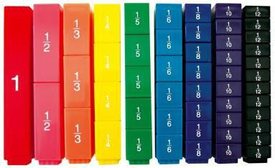  𝟑  3 x =  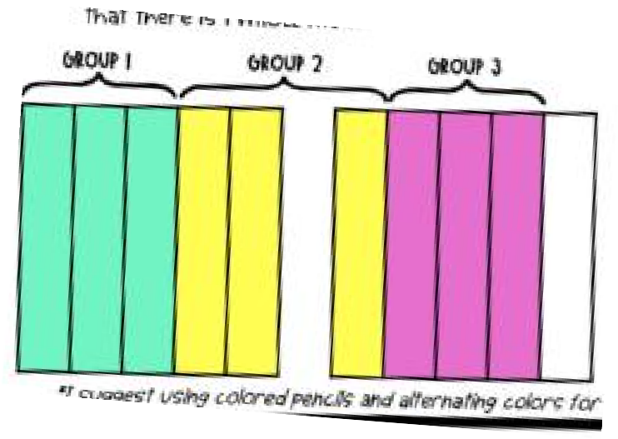  𝟓 | Pupils use bar models to support their understanding.  𝟑  3 x =  𝟒  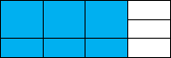  𝟐  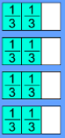  x 4 =  𝟑  Pupils also use a number line to show parts within a whole.  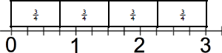  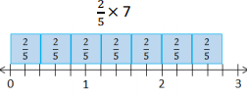  Pupils draw fraction wheels.  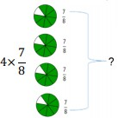 | Pupils show how they have multiplied the numerator, whereas the denominator has not changed. They record their answers in the simplest form.  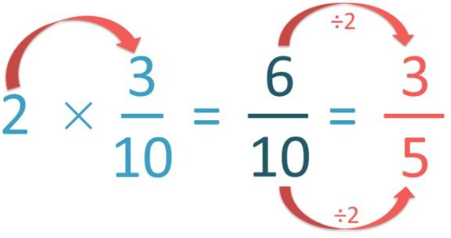  x 2  Once secure using the method with simpler fractions and whole numbers, pupils can use a more formal jotting.  3 5 × 3 15  5 × = =  8 8 8  15 1  = 1  8 7

 | Small Step | Guidance | Concrete | Pictorial | Abstract
Year Five | Multiply mixed numbers by whole numbers | As before, when multiplying mixed numbers by a whole integer, pupils will need to understand why it is only the numerator that changes, whereas the denominator remains the same.  Pupils need to be confident in converting mixed numbers to improper fractions, and vice versa. | Pupils use fraction towers and make paper fraction strips to support their understanding of multiplying mixed numbers.  𝟑 × 𝟏 𝟏 =  𝟒  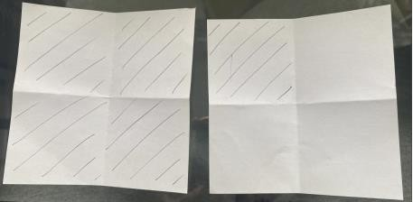  1 5  3 × 1 = 3 ×  4 4 | Pupils draw their own representations, including bar models, to support them with understanding how fractions and wholes are combined, when multiplied.  𝟑 × 𝟏 𝟏 =  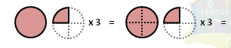  𝟒  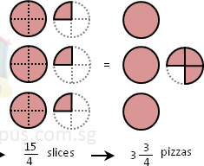  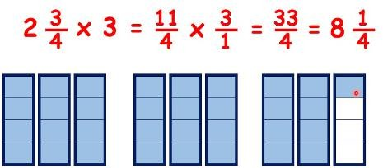  Pupils use bar models to show how fractions are regrouped to make new whole numbers. | With simple fractions, pupils use the grid method to partition the mixed number before multiplying by the whole number.  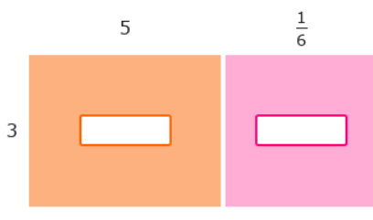  𝟑 × 𝟓 𝟏 =  𝟔  Pupils become automatic in converting mixed numbers in to improper fractions, before multiplying the numerator by the whole number.  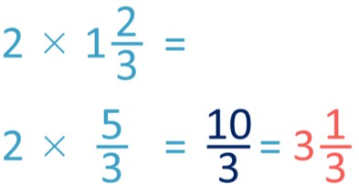  Pupils record answers as mixed numbers in their simplest form.

 | Small Step | Guidance | Concrete | Pictorial | Abstract
Year Six | Multiply numbers with up to 2 decimal places, by whole numbers | Pupils transfer their knowledge of place value and multiplication of whole numbers to multiplication of decimal numbers.  Pupils begin by multiplying decimals with up to 2 decimal places (numbers less than 1), before moving on to wholes and decimals with up to 2 decimal places (numbers greater than 1).  They must have a secure understanding of the value of each digit and avoid simply ‘removing  the decimal point’. | Pupils use decimal hundred squares, with counters or colours.  This reinforces that 1 whole contains 100 hundredths.  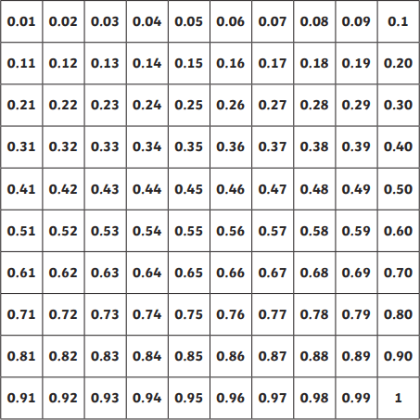  3 × 0.25 =  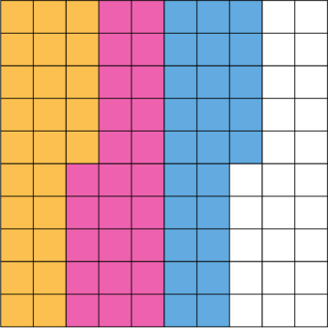 | Pupils use decimal hundred squares to support formation of bar models.  7 x 0.8 =  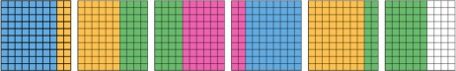  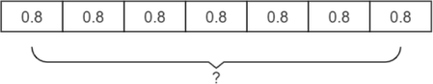  3 x 0.35 =  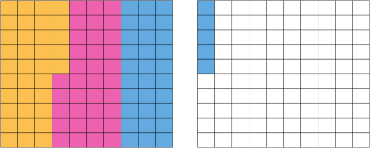  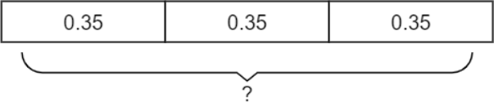  3 x 1.43 =  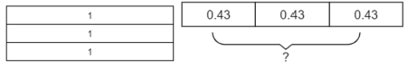 | Pupils know that the single digit, representing the whole number, belongs in the ones column. They line up the decimal points in the question and answer.  3.19 x 8 =  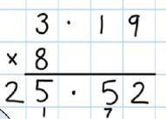  When appropriate, pupils use their knowledge of place value to make the number, that is being multiplied, 10, 100 or 1000 times bigger before multiplying; they then make the answer 10, 100 or 1000 times smaller by dividing.  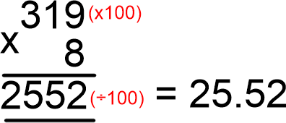

 | Small Step | Guidance | Concrete | Pictorial | Abstract
Year Six | Multiply simple pairs of proper fractions, writing the answer in its simplest form | Pupils understand that when multiplying a fraction with another fraction, both the numerators and the denominators are multiplied.  This is a change from previous learning, where the denominator has remained unchanged. | Pupils select appropriate manipulatives, when necessary. | Pupils draw diagrams to support their understanding of multiplying fractions.  Pupils combine the drawings to identify how many boxes have both colours.  𝟐 𝟑  x =  𝟕 𝟓  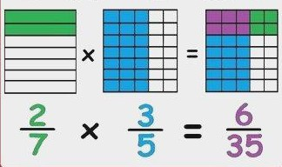  𝟑 𝟒  x =  𝟖 𝟓  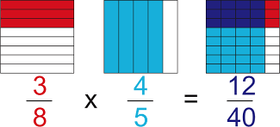  12 3  =  40 10 | Pupils multiply the numerators, then they multiply the denominators. Where needed, the answer is then simplified.  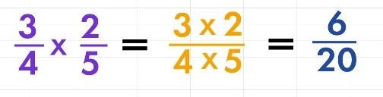  𝟔 𝟑  =  𝟐𝟎 𝟏𝟎  Pupils use this strategy when problem solving.  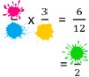

Division

Pre-school | Guidance
Pre-school | Pupils are introduced to the concept of sharing through practical games and activities. They act out sharing through activities such as sharing food for a Teddy Bears’ Picnic or sharing resources equally to play a game. This is reinforced by opportunities provided in the outdoor area for the pupils to share out objects such as building blocks.

 | Small Step | Guidance | Concrete | Pictorial | Abstract
Reception | Share into equal groups | Pupils need to have a secure knowledge of counting backwards, number facts and subtraction in order to halve and share.  Pupils need to experience sharing using a range of objects. | Pupils share a set of objects into equal parts and work out how many are in each part.  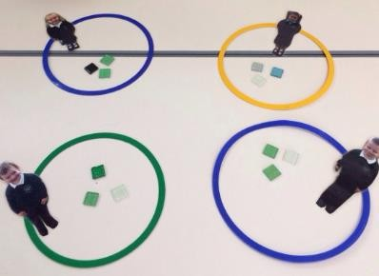  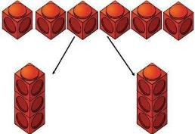 | Pupils draw or colour pictures or shapes to share quantities.  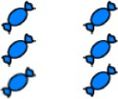  Pupils share quantities using part-whole models and bar models.  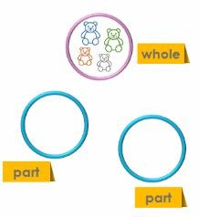 | With support, pupils complete rehearsed sentence stems.  Share 6 buns between two people.  ‘6 buns shared between two people means they get buns each.’

 | Small Step | Guidance | Concrete | Pictorial | Abstract
Year One | Make equal groups | Pupils learn to make equal groups from a whole and find how many equal groups of a certain size can be made.  Pupils start with a given total and make groups of an equal amount.  They record their understanding in sentences, not through formal division at this stage.  Pupils should be able to make equal groups to demonstrate their understanding of the word ‘equal’. | Pupils sort a whole set of children and objects into equal groups.  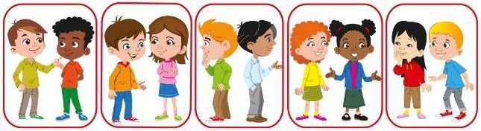  There are 10 children altogether.  There are 2 in each group.  There are 5 groups.  Pupils divide quantities in to equal groups. They use cubes, counters or objects to support understanding.  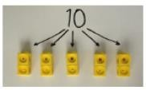  Beadstrings reinforce the concept of equal groups. | Pupils represent a whole and work out how many equal groups.    There are 10 in total.  There are 5 in each group.  There are 2 groups.  Pupils can develop their understanding of equal groups by also being exposed to numbers which do not group equally.  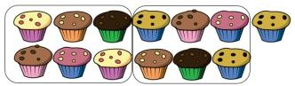 | With support, pupils complete rehearsed sentence stems.  There are in total.  There are in each group.  There are groups.  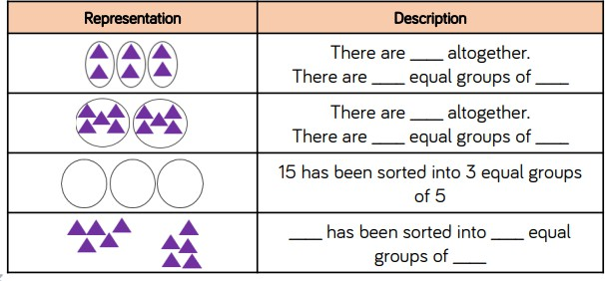

 | Small Step | Guidance | Concrete | Pictorial | Abstract
Year One | Solve 1-step problems using sharing | Pupils solve problems by sharing objects and quantities into equal groups.  Pupils explore sharing as a model of division. They use 1 : 1 correspondence to share concrete objects into equal groups. Pupils are not expected to divide formally. | Pupils share using a range of objects.  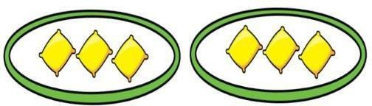    They apply their understanding of sharing within physical bar models and part-whole models.  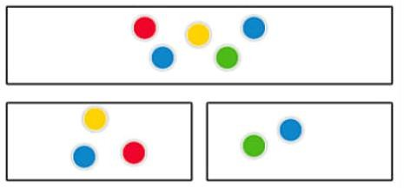  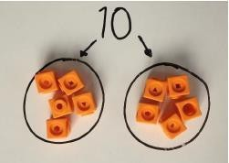 | Pupils draw pictures or shapes to share quantities.    Pupils use bar modelling to show and support understanding.  6 divided by 2 is …  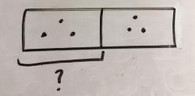  A teacher shares 12 counters between 4 children.  How many counters do they get each?  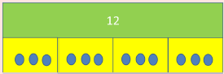 | Pupils complete sentence stems and link division with repeated addition.  ‘6 shared between 2 is 3’  ‘3 + 3 + 3 + 3 is equal to 12’

 | Small Step | Guidance | Concrete | Pictorial | Abstract
Year Two | Divide using repeated subtraction | Pupils are introduced to the division symbol. They will begin to see the link between division and multiplication.  Pupils should also be encouraged to use known times tables facts, where appropriate. | Pupils carry out repeated subtraction using Cuisenaire rods above a ruler.  3 groups of 2  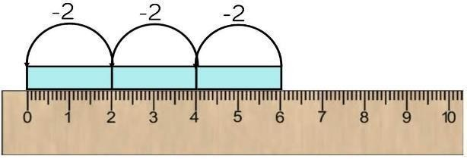 | Pupils represent repeated subtraction pictorially, using structured number lines and then creating their own.  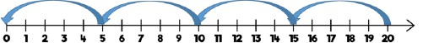  Pupils show jumps in groups. They understand that the number of jumps is the number of groups.  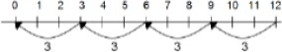  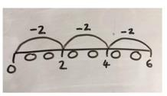 | Pupils become secure with representing division as an abstract number sentence using the division and equals symbol.  They use an abstract number line to represent the equal groups that have been subtracted.  6 ÷ 3 = 2  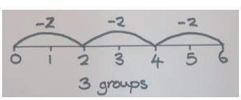

 | Small Step | Guidance | Concrete | Pictorial | Abstract
Year Two | Share grouped objects equally using arrays | Pupils solve problems by grouping and counting the number of groups.  Grouping encourages pupils to count in multiples and links to repeated subtraction on a number line. | Pupils use concrete representations in fixed groups, such as number shapes, to show the links between multiplication and division.  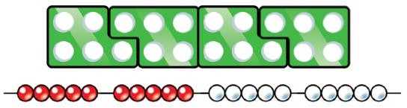  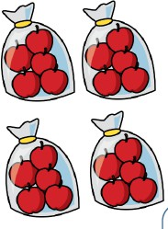  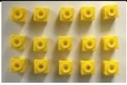  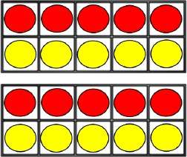 | Pupils draw arrays once they are secure at drawing equal groups of objects.    Pupils draw lines to divide their arrays in to groups.    They represent their understanding of arrays on bar models.  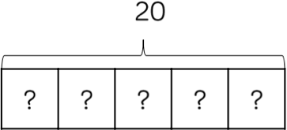 | Pupils focus on efficient strategies, and whether they should use grouping or sharing, depending on the context of the question.  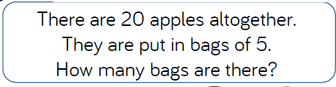  20 ÷ 5 = 4 or 20 ÷ 4 = 5 ?  Pupils create linking number sentences to show the relationship between division and multiplication.  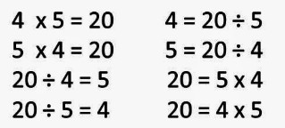

 | Small Step | Guidance | Concrete | Pictorial | Abstract
Year Three | Divide 2-digits by 1-digit, sharing with no exchange | When dividing larger numbers, pupils use manipulatives that allow them to partition into tens and ones.  They divide numbers that do not involve exchange or remainders.  It is important that pupils divide the tens first and then the ones. | Pupils use straws, base 10 and place value counters to share 2-digit numbers into equal groups.  48 ÷ 2 =  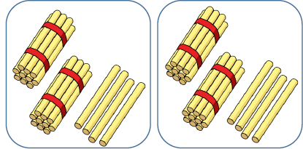  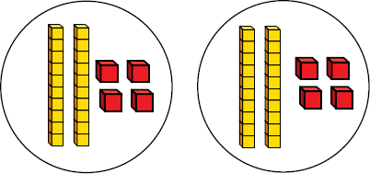  They confidently use place value grids and partitioning to support their understanding.  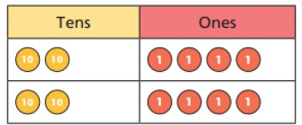 | Pupils use part-whole models, which provide them with a clear representation that matches the concrete resources.  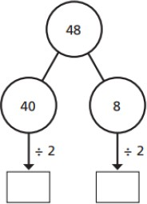 | Pupils use known times-tables facts to support partitioning numbers into multiples of the divisor.  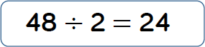

 | Small Step | Guidance | Concrete | Pictorial | Abstract
Year Three | Divide 2-digits by 1-digit, with exchanges - with no remainders | Pupils divide 2-digit numbers by a 1-digit number by partitioning into tens and ones and sharing into equal groups.  They divide numbers that involve exchanging between the tens and ones. The answers do not have remainders.  Pupils use the times-tables facts that they know to partition the number into multiples of the divisor. | When dividing numbers involving an exchange, pupils use base 10 and place value counters to exchange one ten for ten ones.  Pupils should start with equipment outside the place value grid before sharing the tens and one equally between the rows.  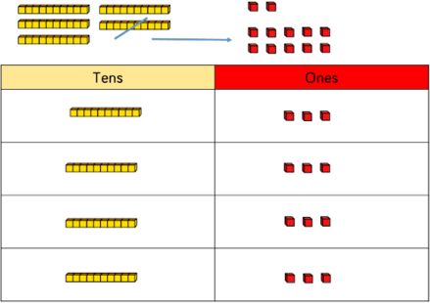  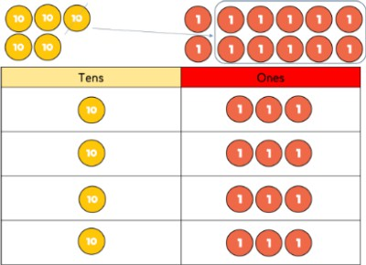 | Pupils represent the place value counters pictorially.  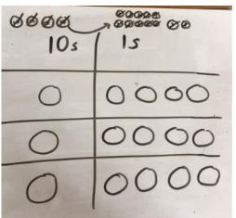  Pupils use bar models to demonstrate their understanding of division.  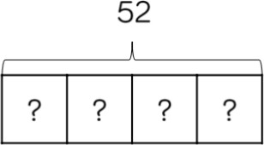  They use flexible partitioning, in the part-whole model, to support this method.  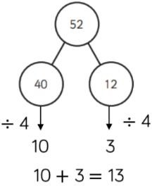 | Pupils record their calculation within number sentences containing the division symbol.  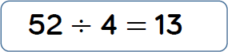

 | Small Step | Guidance | Concrete | Pictorial | Abstract
Year Three | Divide 2-digits by 1-digit, with exchanges and with remainders | Pupils develop their understanding of equal groups by also being exposed to numbers which do not group equally, within the tables that they know.  Pupils move onto solving division problems with a remainder. Links are made between division and repeated subtraction, which builds on learning in Year 2. | Pupils divide using lollipop sticks or Cuisenaire rods to form wholes.  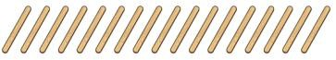  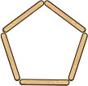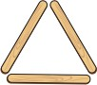    Pupils use Base 10 and place value counters to exchange one ten for ten ones.  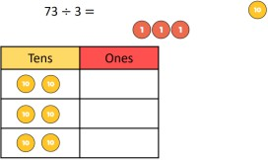  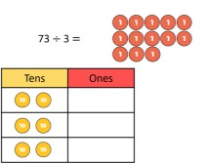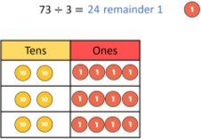  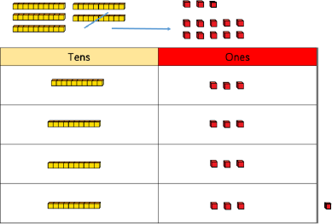 | Pupils represent the lollipop sticks pictorially.  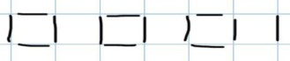  ‘There are 3 whole squares, with 1 left over.’  Pupils use repeated subtraction on a number line to divide.  13 ÷ 4 =  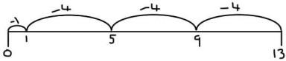  They show their understanding on bar models and part-whole models which use flexible paritioning.  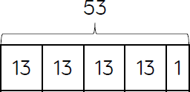  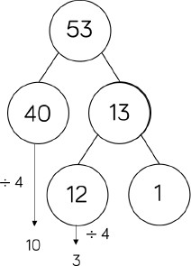 | Pupils record the remainders. This notation is new to Year 3 so will need a clear explanation.  13 ÷ 4 = 3 remainder 1  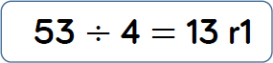

 | Small Step | Guidance | Concrete | Pictorial | Abstract
Year Four | Divide 3-digits by 1-digit, with exchanges and remainders | Pupils continue to use place value counters to share 3-digit numbers into equal groups.  Pupils start with the equipment outside the place value grid before sharing the hundreds, tens and ones equally between the rows.  This method can also help to highlight remainders. | Pupils are introduced to short division, using place value counters to group and exchange.  844 ÷ 4 =  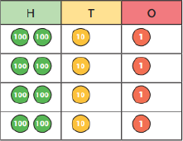  856 ÷ 4 =  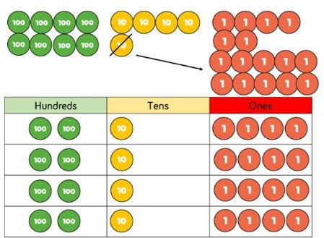 | Pupils use drawn diagrams with dots or circles to help them divide numbers into equal groups.  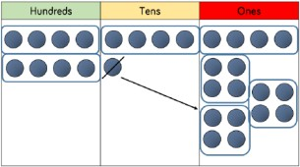  Pupils use grouping and partitioning to support their understanding of short division, when dividing a 3-digit number by a 1-digit number.  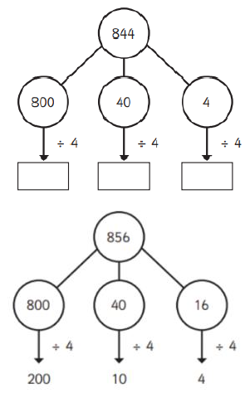  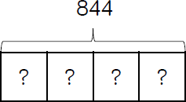 | Pupils move towards counting in multiples in order to divide more efficiently.  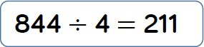  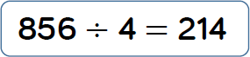  Pupils may be introduced to short division (bus stop method) if they are ready.  When introduced, pupils begin with divisions that divide equally with no remainders.  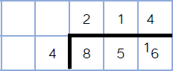  They then move onto divisions with a remainder.  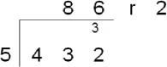

 | Small Step | Guidance | Concrete | Pictorial | Abstract
Year Five | Divide 4-digits by 1-digits, using short division | Pupils use grouping when using the short method of division. Starting with the largest value, they group by the divisor.  Language is important: pupils should consider how many groups of tens and ones can be made. | Pupils use place value counters or plain counters, to group on a place value grid, exchanging where needed.  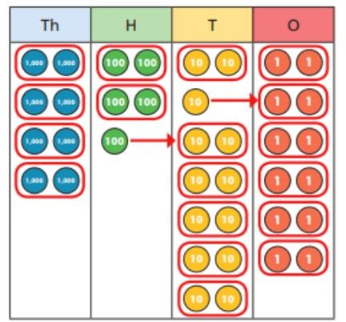  Pupils clearly see remainders, as there are place value counters, which are left ungrouped. | Pupils draw their own counters and group them through a more pictorial method, if needed. | Pupils move away from the concrete and pictorial when dividing numbers with multiple exchanges.  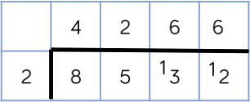  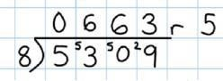

 | Small Step | Guidance | Concrete | Pictorial | Abstract
Year Six | Divide 4-digits by 2-digits, using short division | Pupils begin to divide up to 4-digits by 2-digits selecting written methods as their most accurate method.  Pupils will also solve problems with remainders where the quotient can be rounded as appropriate. | Pupils select appropriate manipulatives, when necessary. | Pupils draw representations, as appropriate. | Pupils write out multiples to support their calculations with larger remainders.  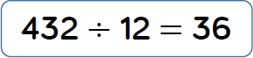  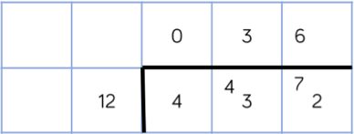  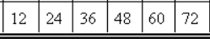  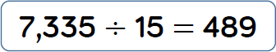  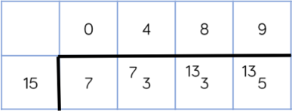  Pupils may record the remainder as decimals or fractions.

 | Small Step | Guidance | Concrete | Abstract
Year Six | Divide 4-digits by 2-digits, using long division | Pupils divide larger numbers using long division.  When a remainder is left at the end of a calculation, pupils can either leave it as a remainder or convert it to a fraction or decimal.  This will depend on the context of the question.  Pupils can also answer questions where the quotient needs to be rounded according to the context. | Pupils use place value counters to initially support their understanding of long division; counters are used alongside the written formal method.  2544 ÷ 12 =  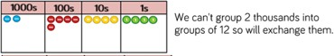  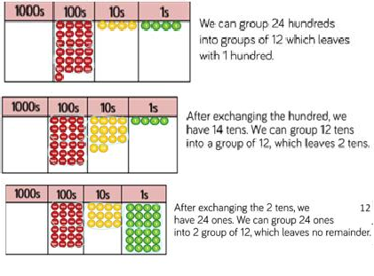 | Pupils are introduced to the long division method using a 1-digit divisor.  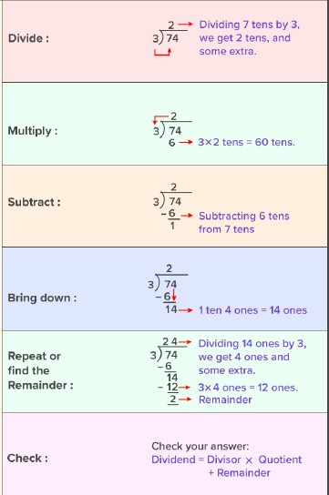  They then apply this to smaller numbers with a 2-digit divisor.  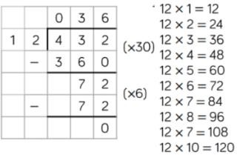 | Pupils write out multiples first when moving on to long division with a 2-digit divisor.  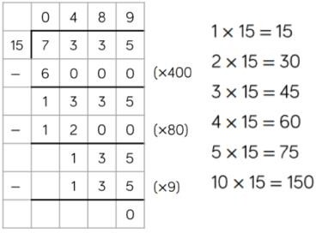  Pupils record the remainder as a fraction.  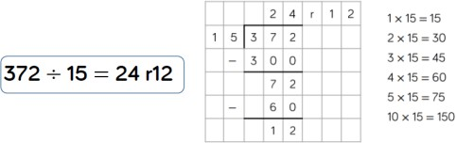  ‘12 is ⁴ of 15’  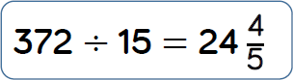  5  They also record decimal remainders.  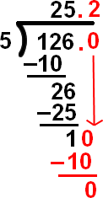

 | Small Step | Guidance | Concrete | Pictorial | Abstract
Year Six | Divide proper fractions by whole numbers | Pupils need to understand what happens to the denominator when it is divided by an integer and most importantly, why.  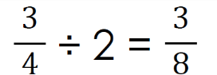  Why have the quarters become eighths? | Pupils use paper strips to demonstrate what happens to a fraction when it is divided by a whole integer, e.g. dividing by 2 = fold the paper in half.  𝟏  ÷ 2 =  𝟐  Pupils fold each half in two parts, so that it becomes clear that quarters have been formed.  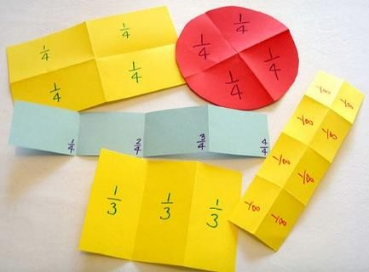 | Pupils use bar models and fraction diagrams to support their understanding of sharing fractions.  𝟐  ÷ 2 =  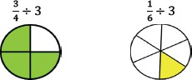  𝟓 | Pupils solve division problems involving fractions and whole numbers.  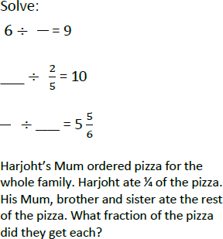

Appendix 1 – Addition and Subtraction Guidance
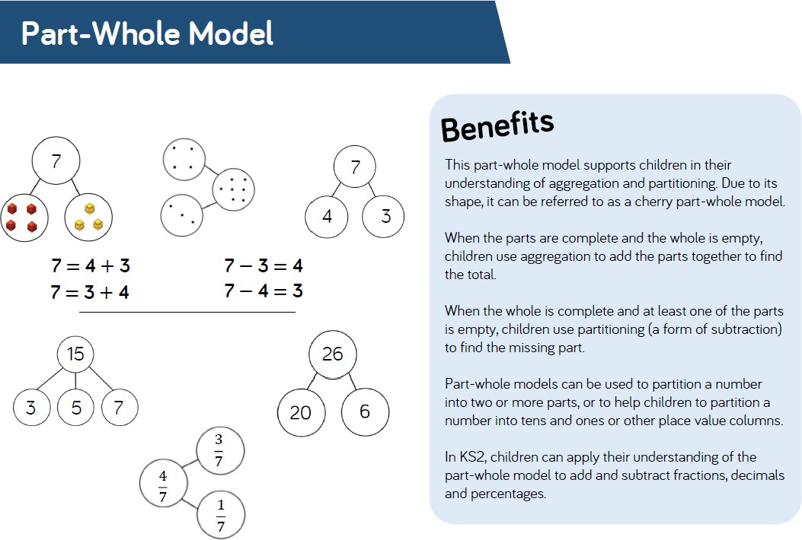
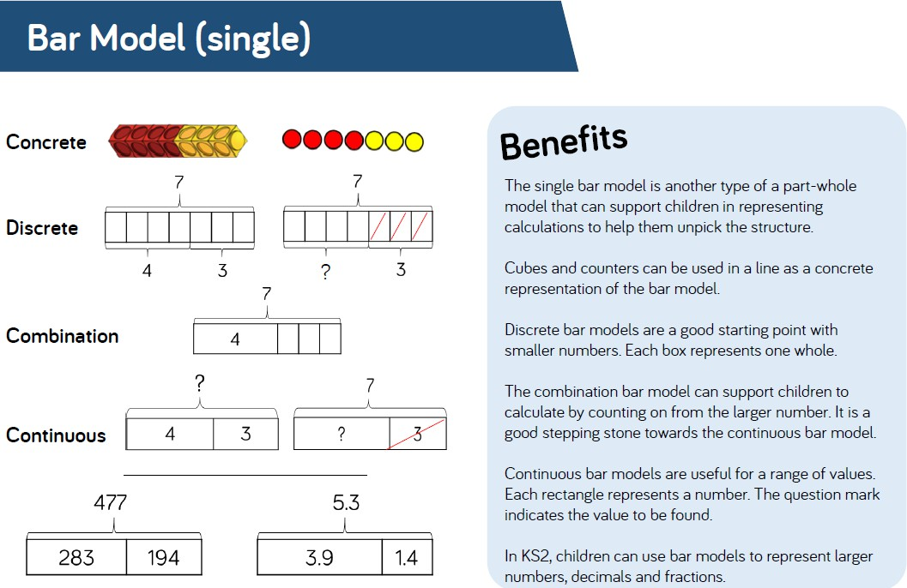

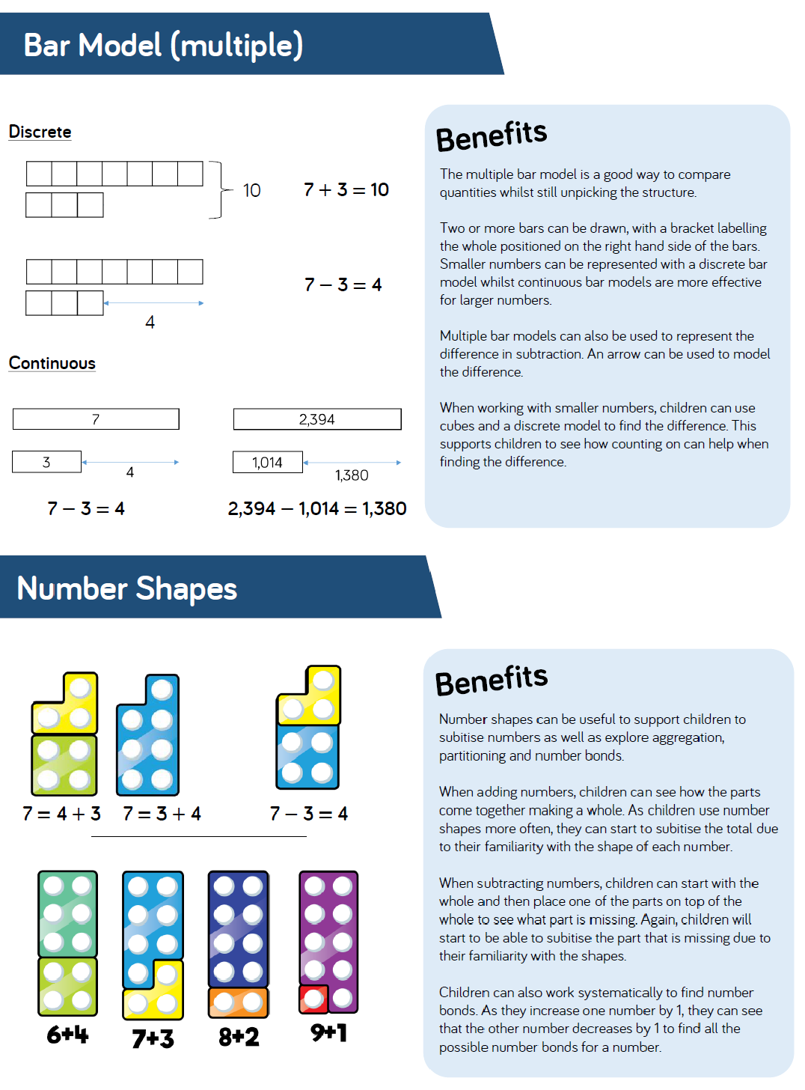

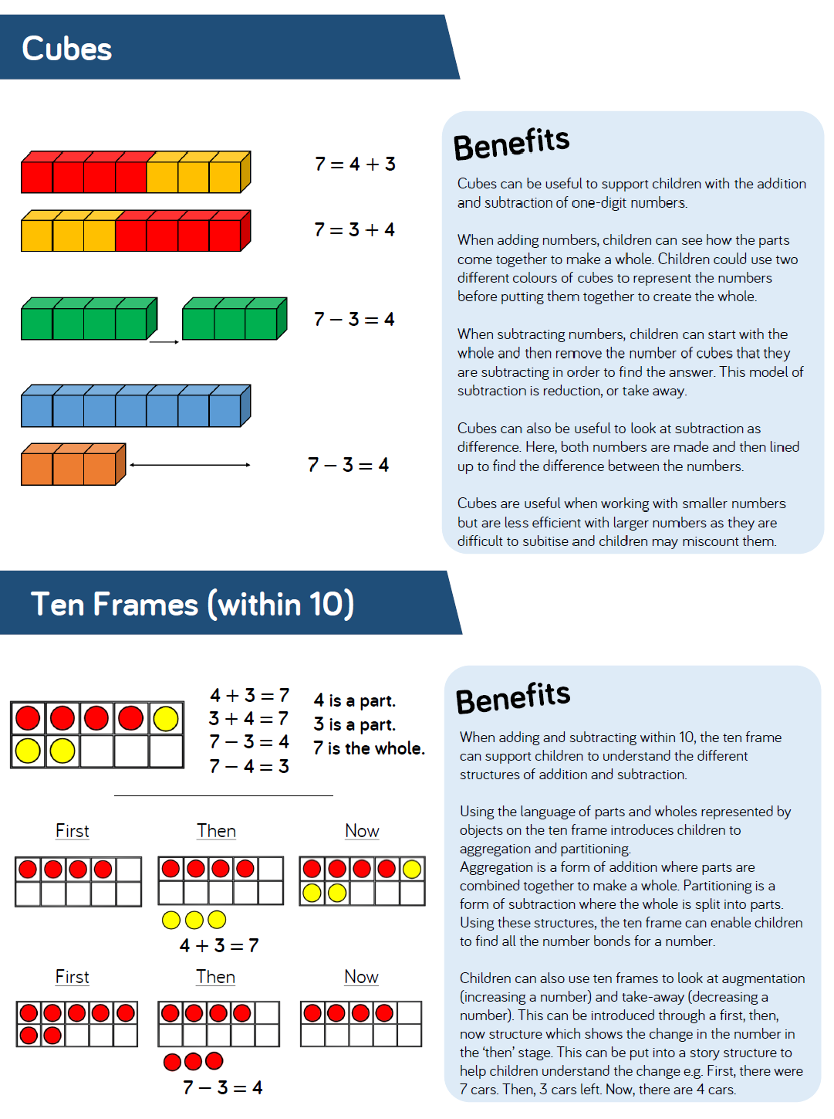

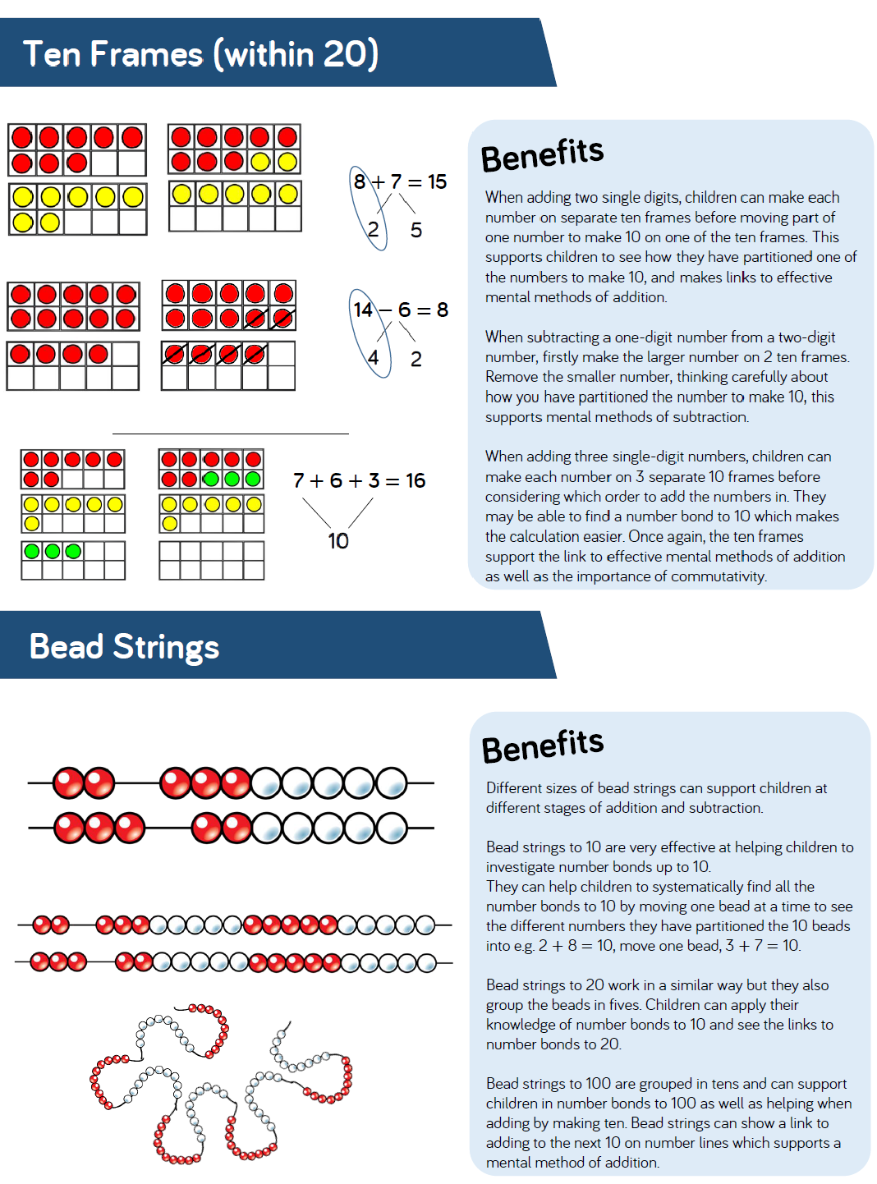

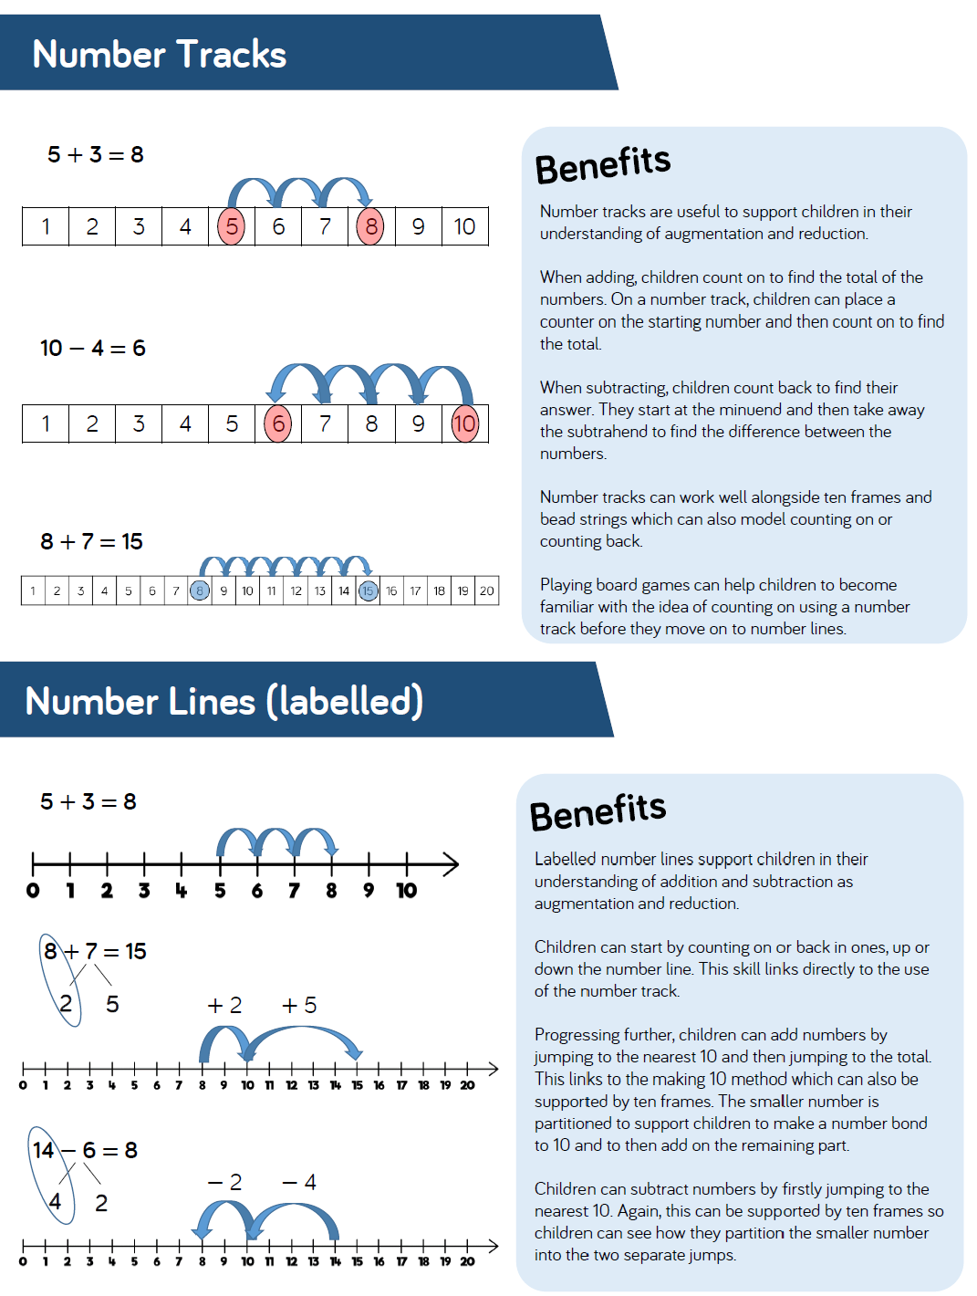

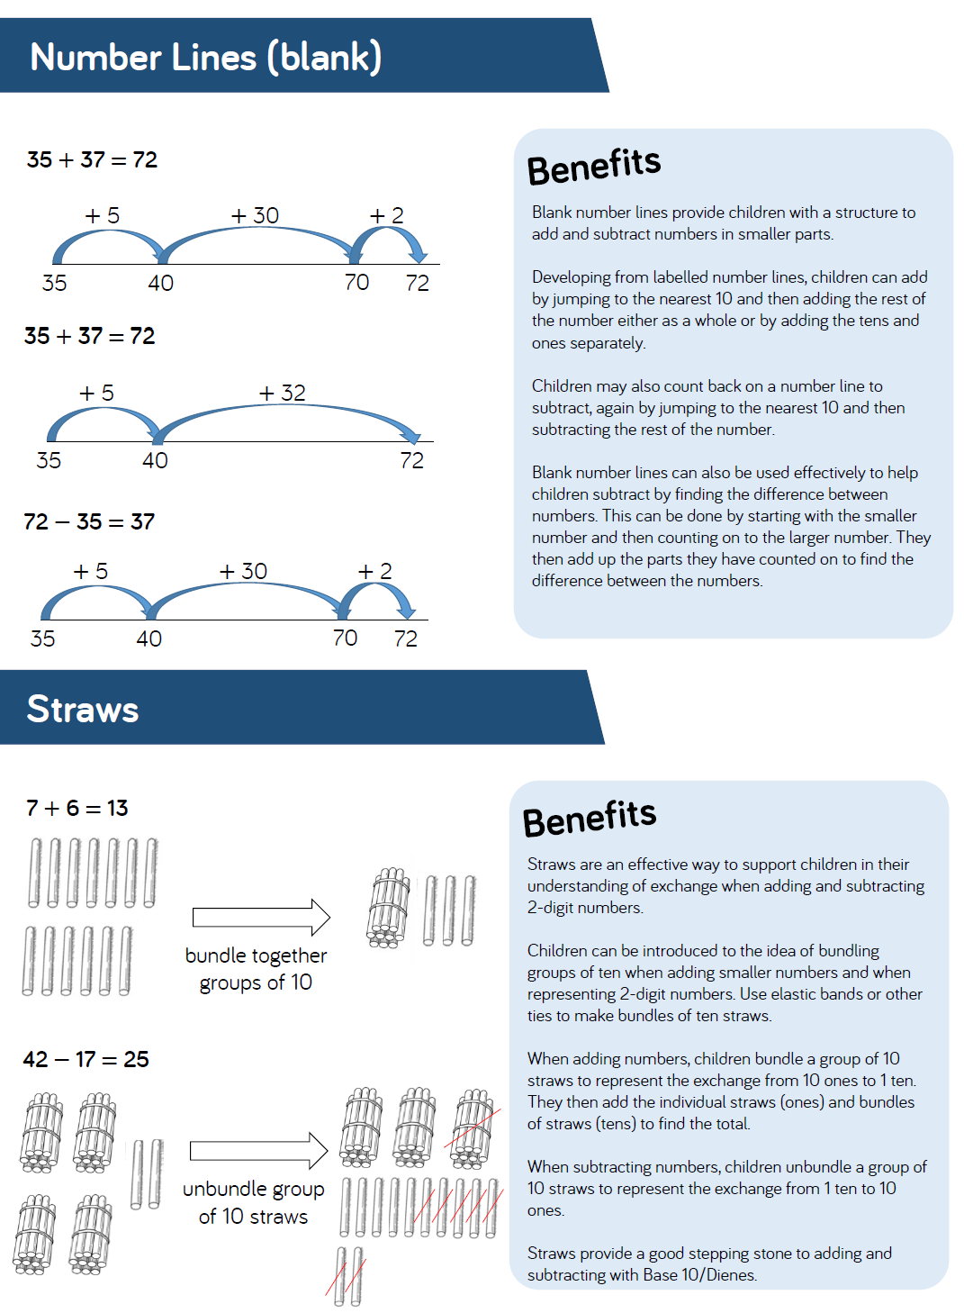

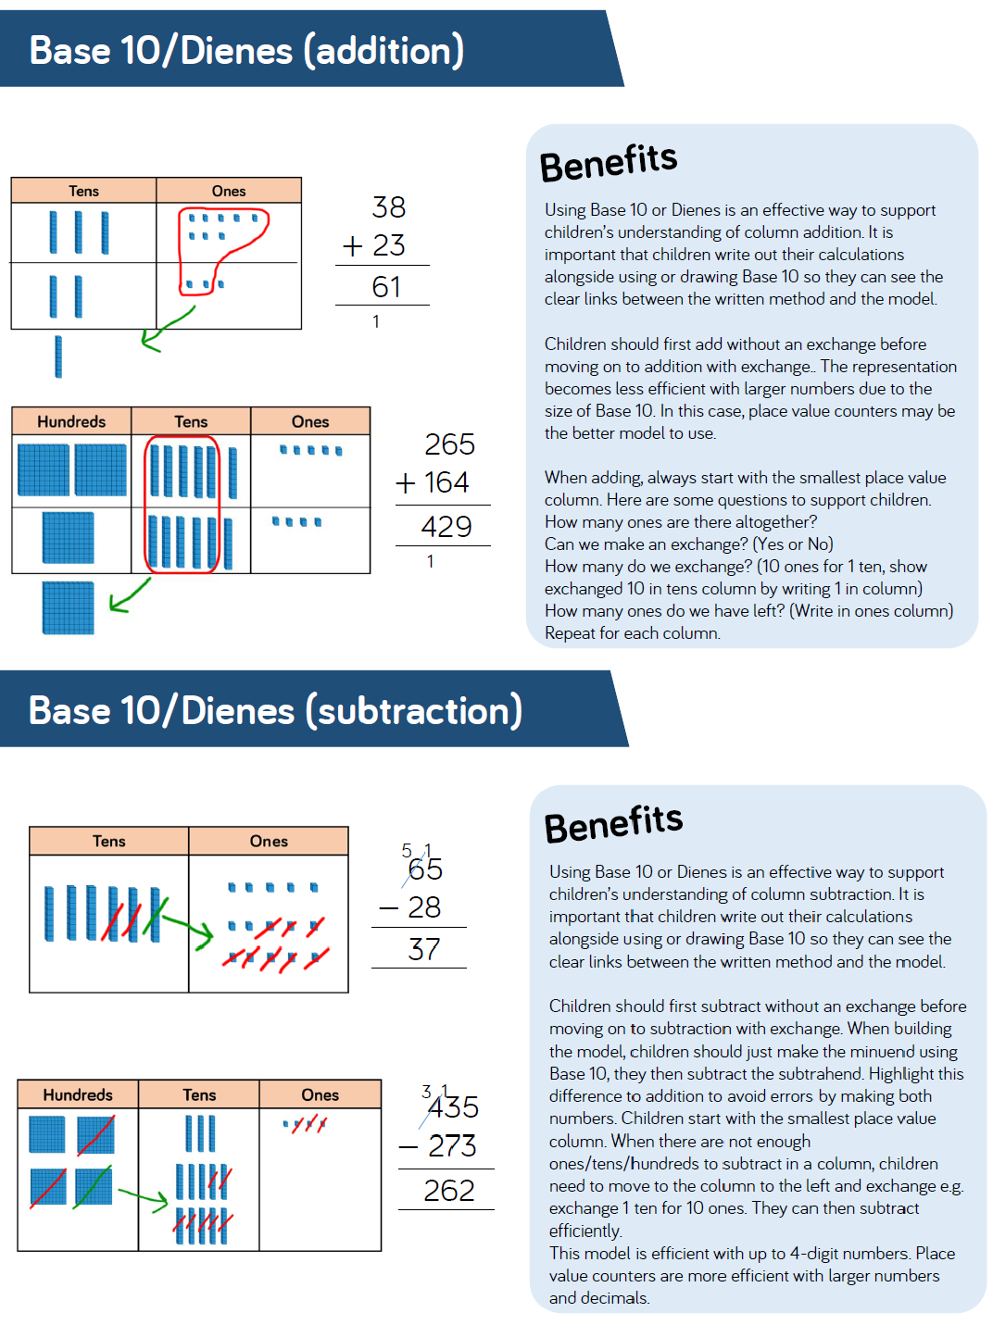

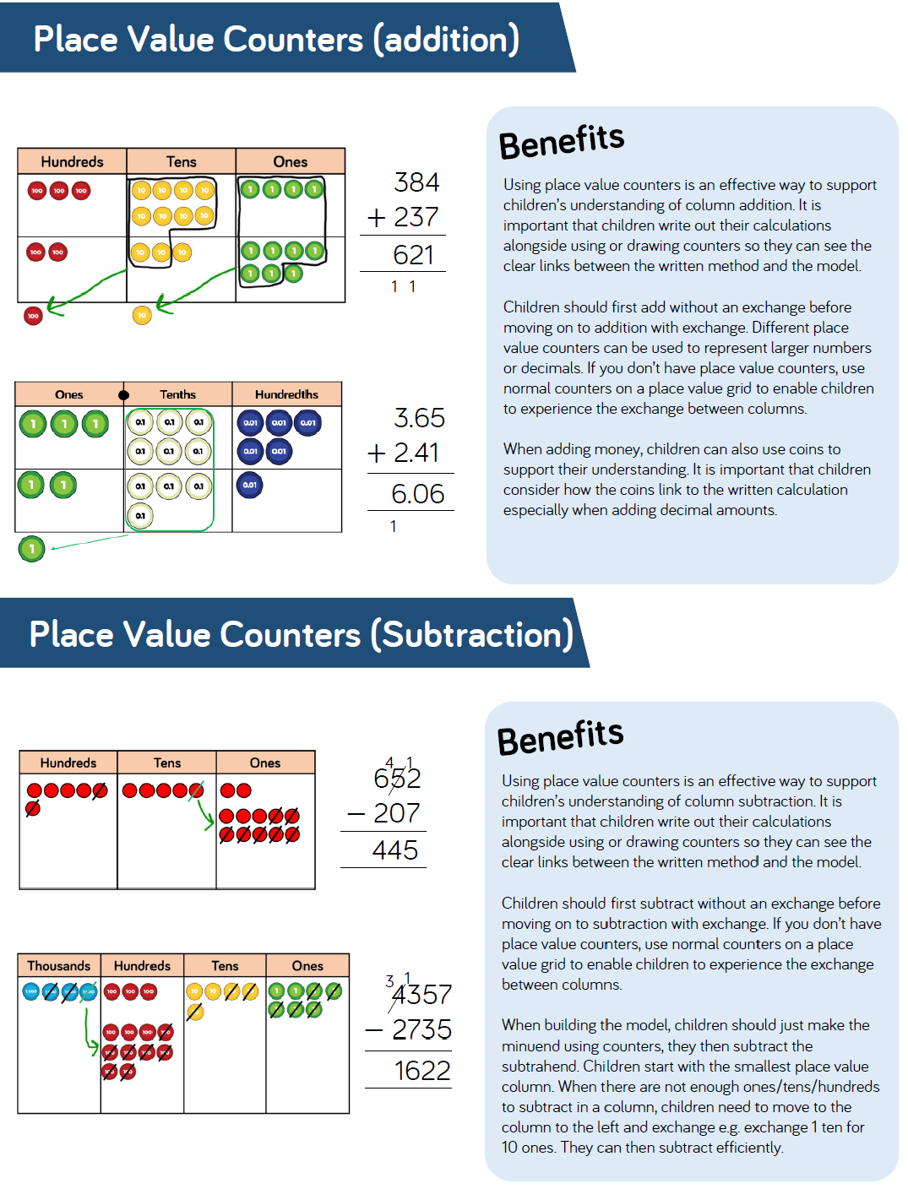

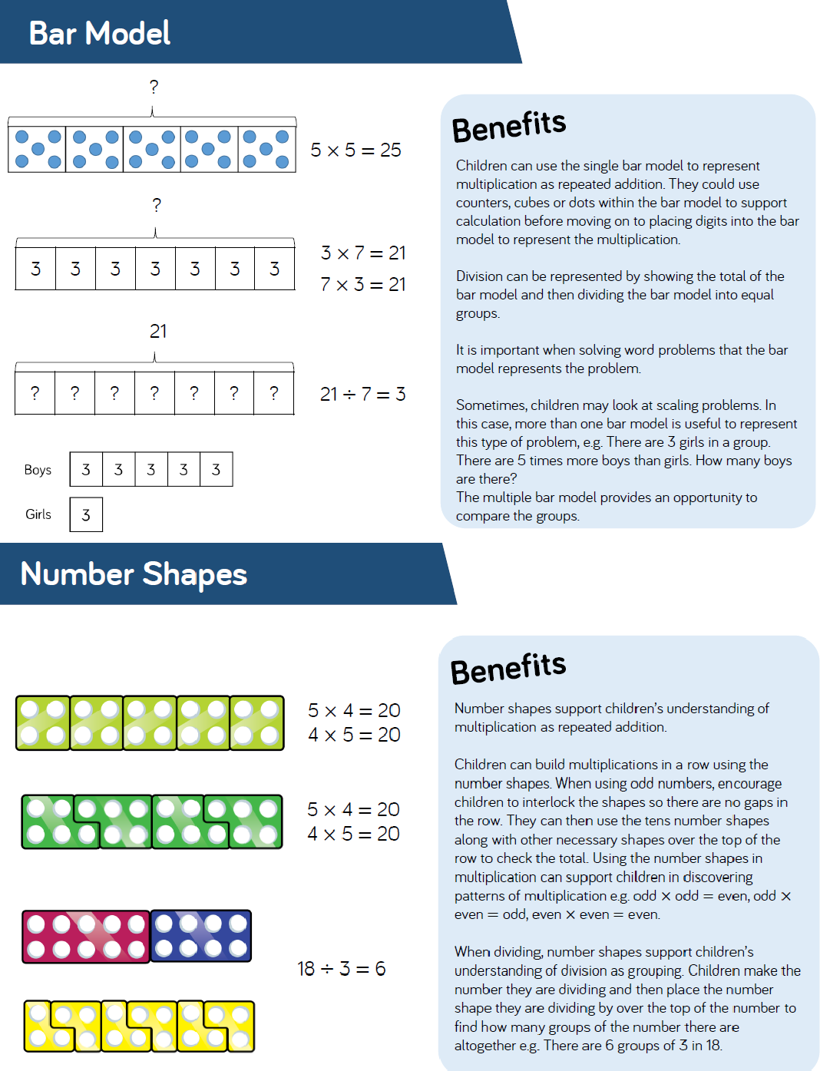
Appendix 2 – Multiplication and Division Guidance

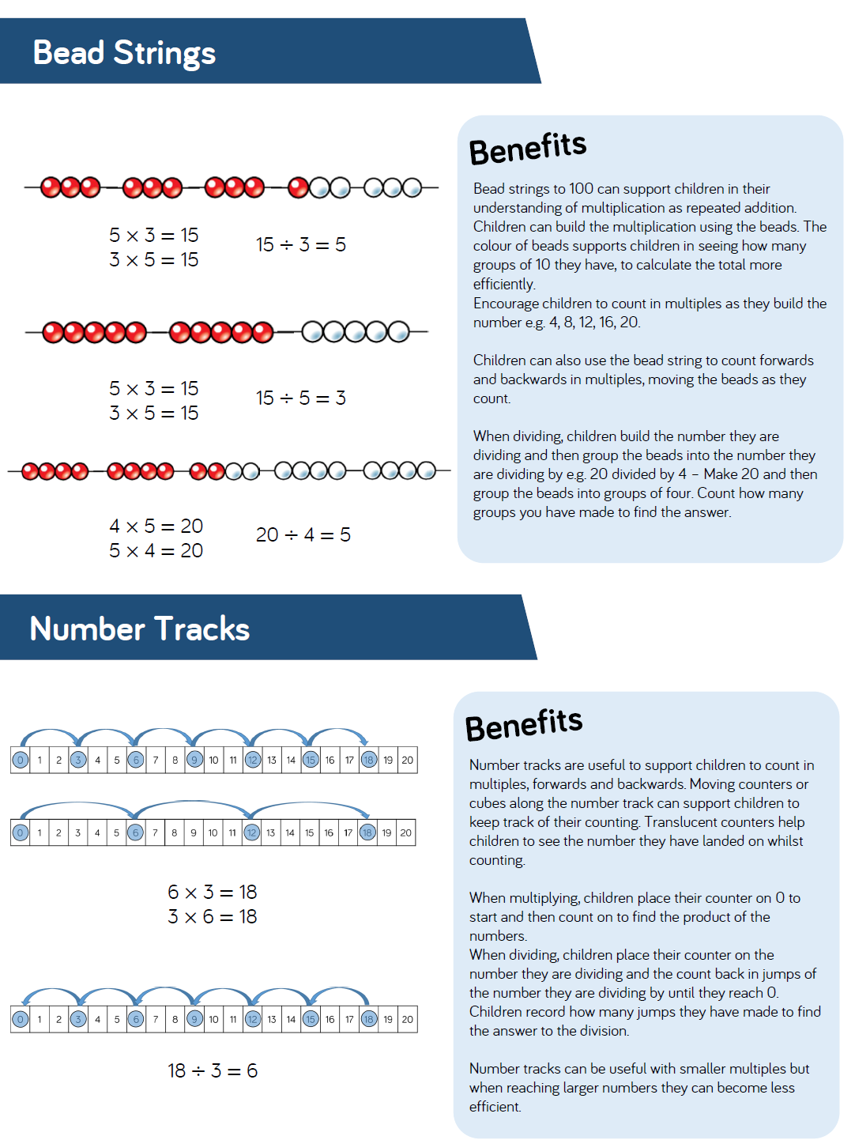

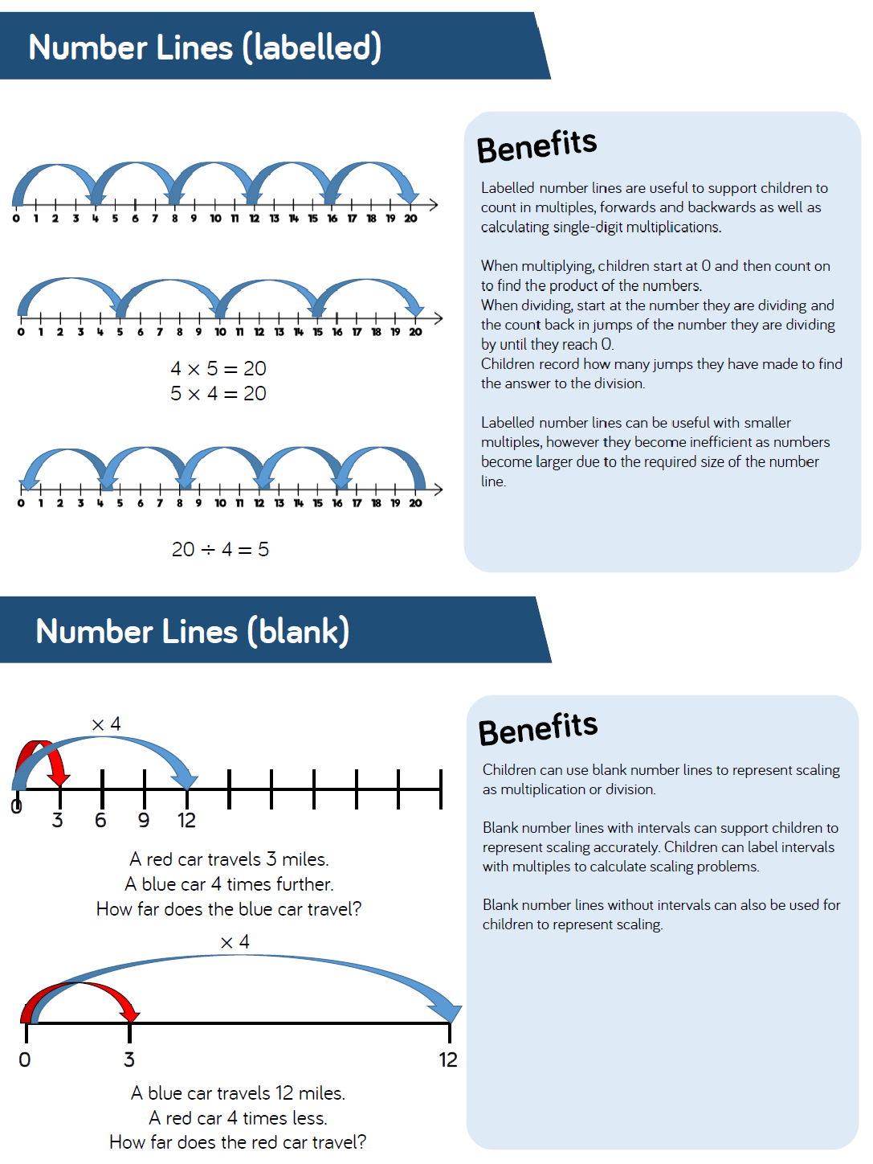

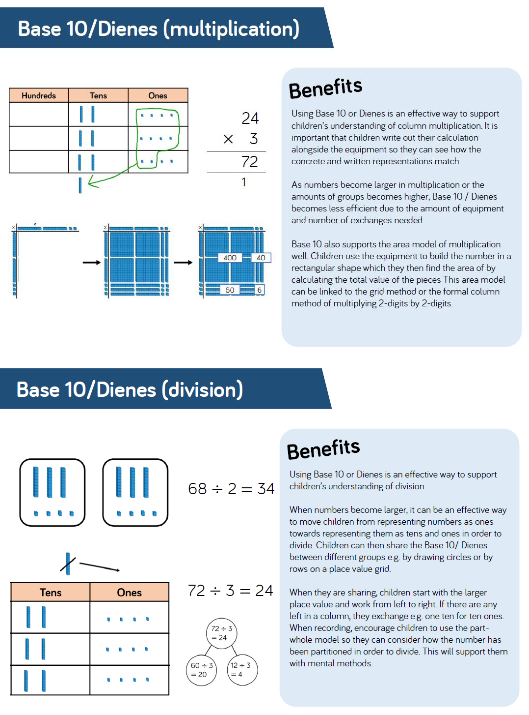

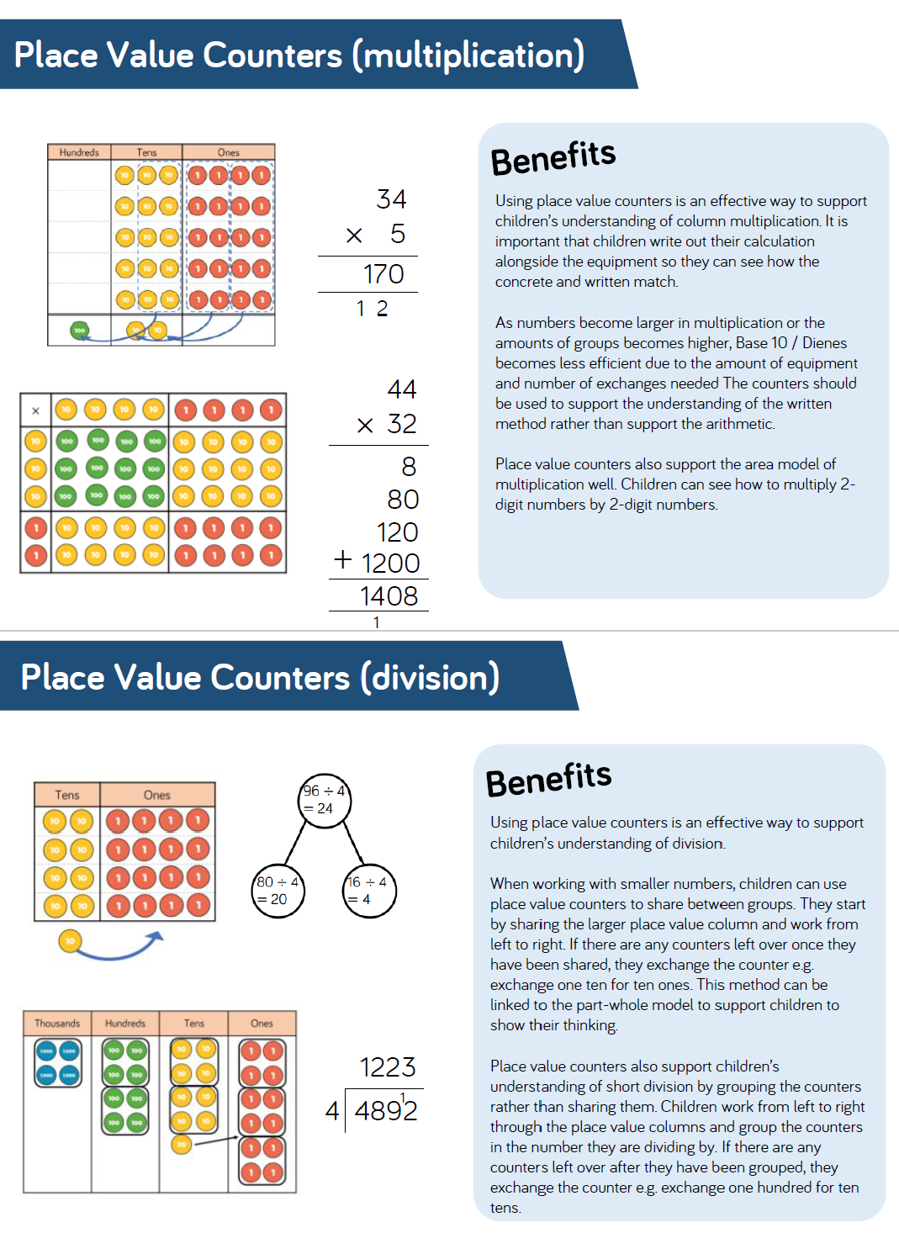

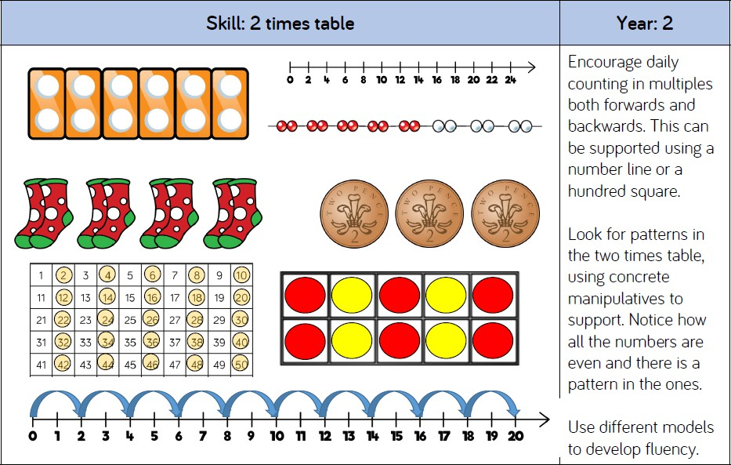
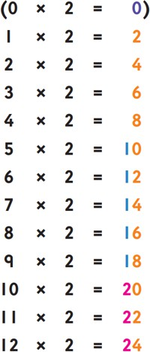
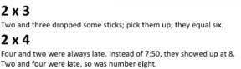
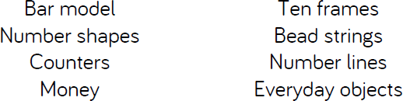
Appendix 3 – Times Tables
Pupils spot the pattern of 0, 2, 4, 6, 8 repeated.
Including 0 × 2, the digits 0, 2, 4, 6 and 8 repeat in the ones
column: 0, 2, 4, 6, 8, 0, 2, 4, 6, 8.
The digit in the tens column goes up one each time the number string starts again.
Another rule for the 2 times table is ‘count a number, miss a number, count a number, miss a number’ and so on.

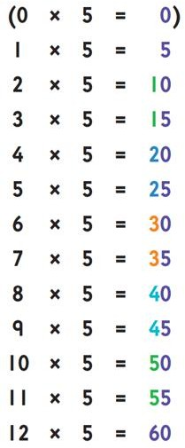
Pupils spot the pattern of 0, 5 repeated.
If 0 × 5 is included, the digits 0 and 5 repeat themselves in the ones column: 0, 5, 0, 5, 0, 5...
The digit in the tens column goes up by 1 each time; then, the pattern starts again.
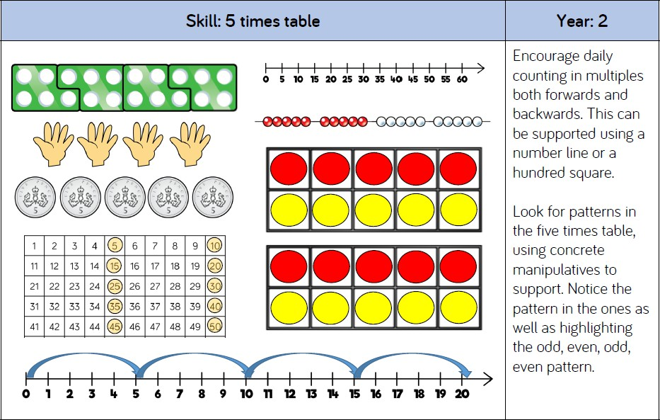

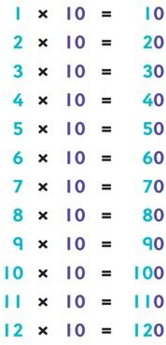
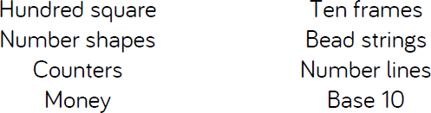
Pupils spot the pattern of putting a zero on the end of the number that is multiplied by 10.
This can be useful to help pupils quickly answer 10 times tables calculations, but it is important for them to understand that although it looks like a zero has just been placed on the end of the number, the digits have actually moved to the left and filled the gap with a place holder (0).
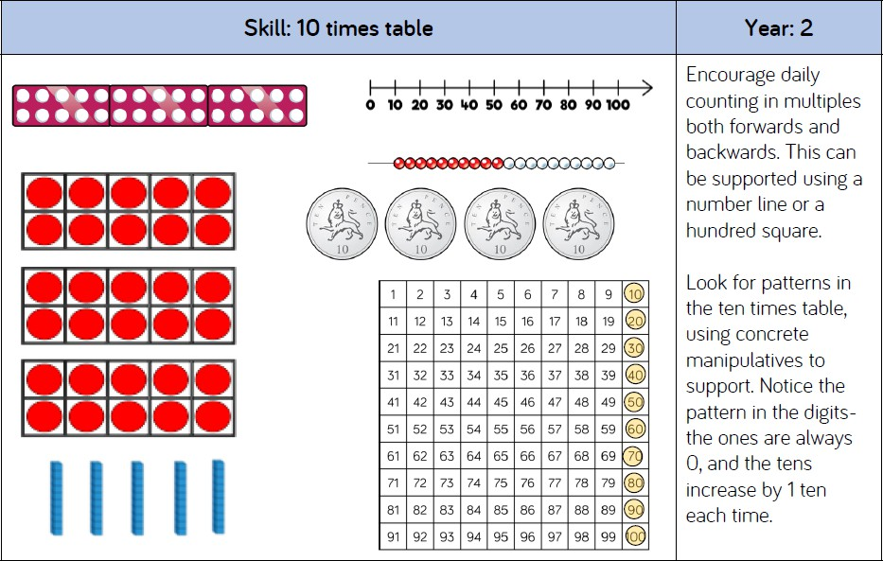

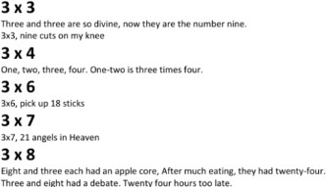
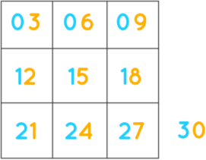
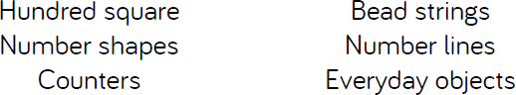
Pupils spot that the 3 times table doesn’t have any rules, but there is a pattern for every ten multiples of three: 3, 6, 9, 12, 15, 18, 21, 24, 27, 30.
The last digit of these multiples always repeats: 33, 36, … , and so on
Pupils spot patterns when the multiples of 3 are placed in a three-by-three grid. They notice that the ones and tens are consecutive, when looked at vertically.
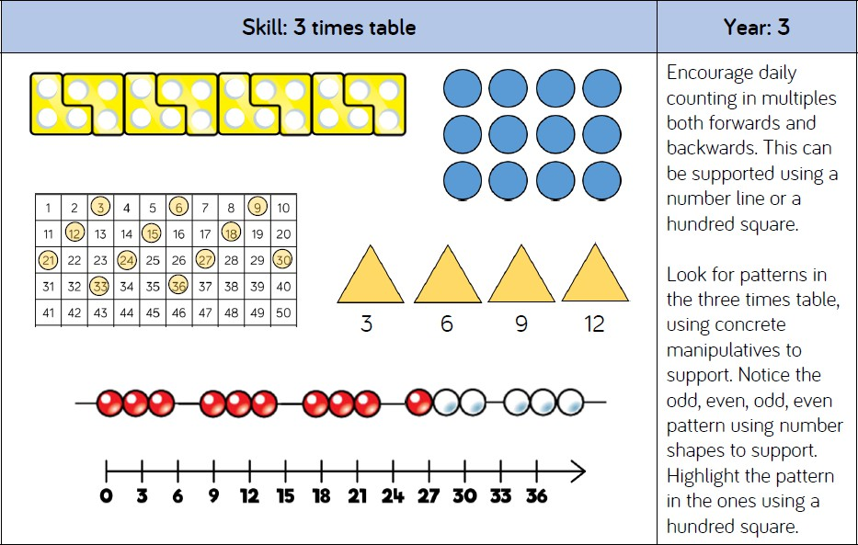

1 x |  | 3 | = 3
2 x |  | 3 | = 6
3 x |  | 3 | = 9
4 x |  | 3 | = 12
5 x |  | 3 | = 15
6 x |  | 3 | = 18
7 x |  | 3 | = 21
8 x |  | 3 | = 24
9 x |  | 3 | = 27
10 | x | 3 | = 30
11 | x | 3 | = 33
12 | x | 3 | = 33

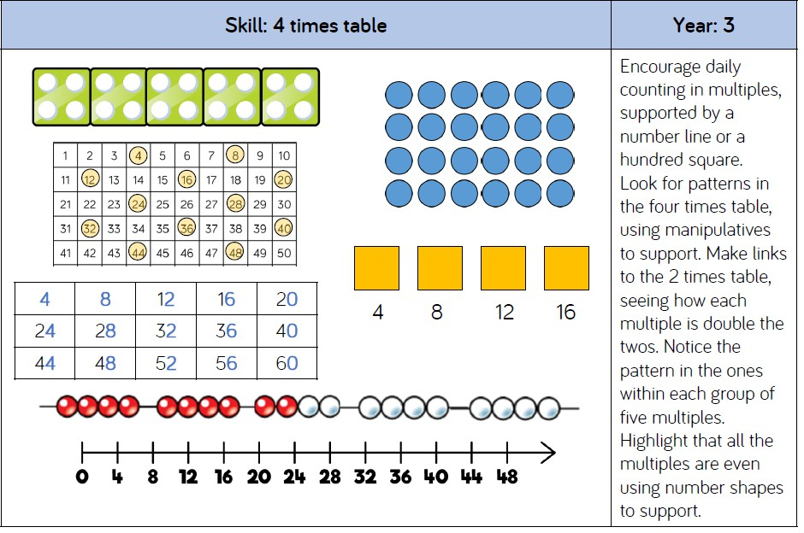
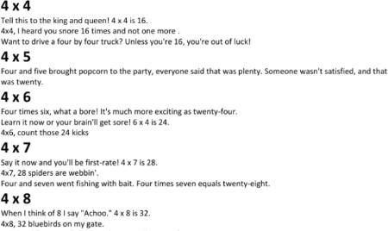
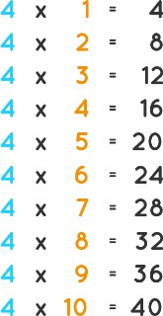
Pupils spot that there is a pattern for every ten multiples of four: 4, 8, 12, 16, 20, 24, 28, 32, 36, 40. The last digit of these multiples always repeats:
44, 48, … , and so on
Pupils use their understanding of the 2 times table to help them identify multiples of 4.

4 | x | 11 | = 44
4 | x | 12 | = 48

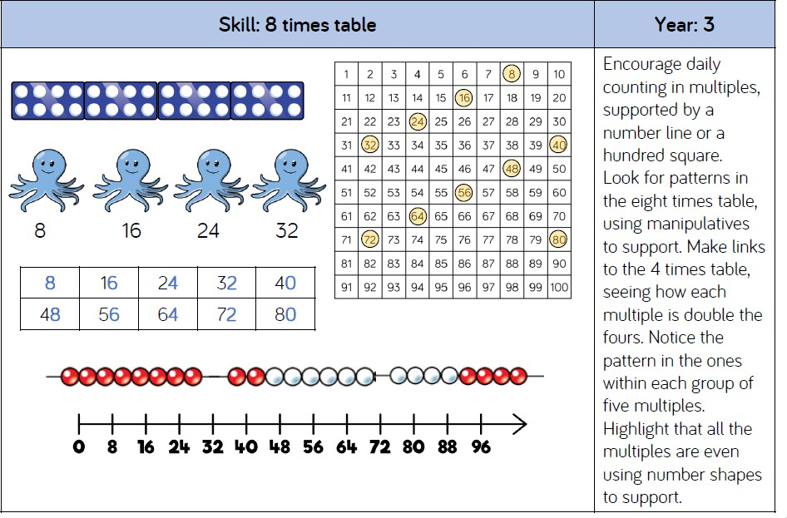
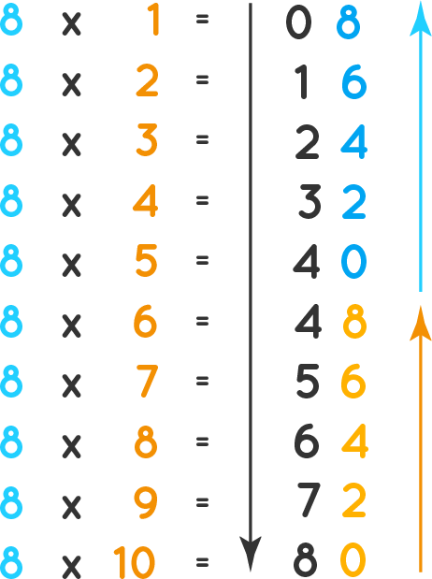
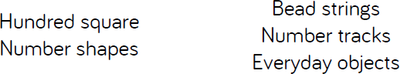
Pupils spot that the last digit of these multiples always repeat.
Pupils notice that the digits which are in the ones column are occurring in a sequence 0, 2, 4, 6, 8 from bottom to top and then repeating. While in the tens column, the numbers are increasing from top to bottom.

8 x 11 | = | 8 8
8 x 12 | = | 9 6

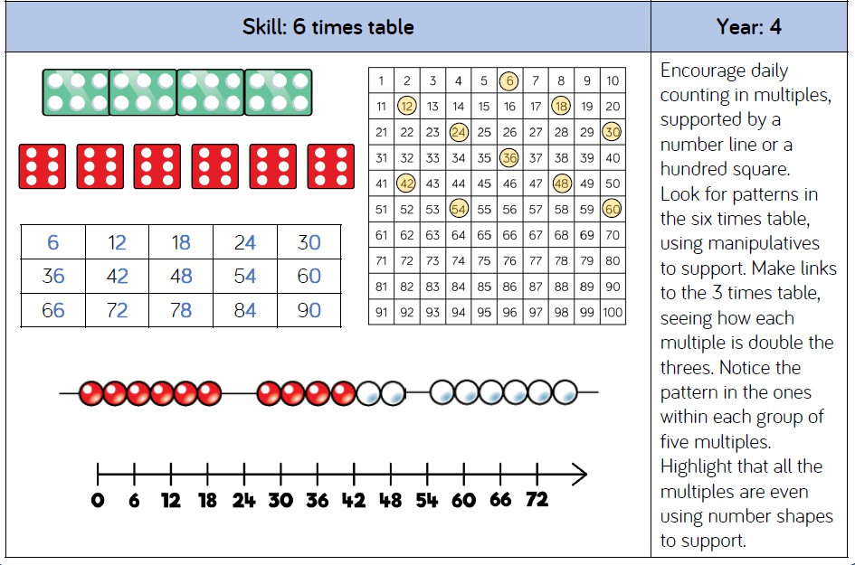
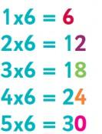
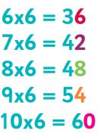
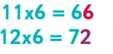
Pupils spot that multiples of 6 are also multiples of 2 and multiples of 3.
Pupils spot that the ones digits repeat in a pattern: 6, 2, 8, 4, 0, 6, 2, 8, 4, 0.
Pupils spot that when an even number is multiplied by 6, the last digit remains the same, e.g. 6 × 4 = 24, 6 × 6 = 36, 6
x 8 = 48.

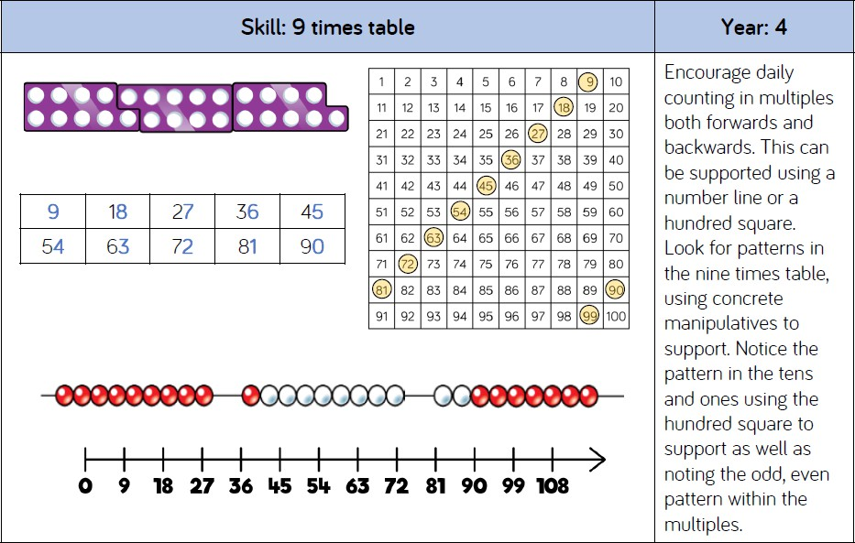
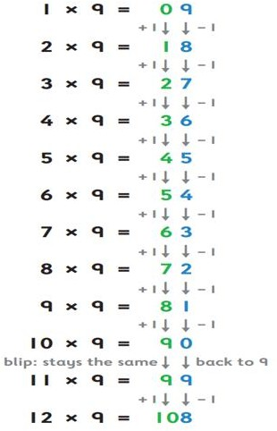
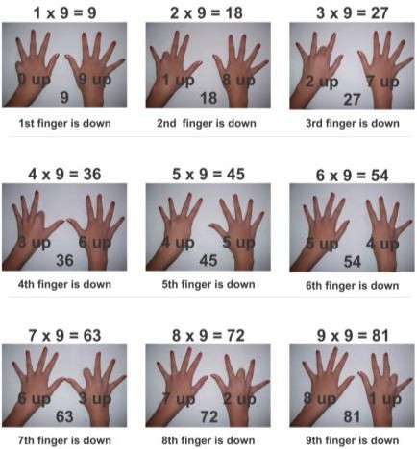
Pupils spot the pattern of the ones digit goes down in ones and the tens digit goes up in ones.
(pupils notice that there’s a blip at 11 × 9, but that the pattern picks up again)… ‘11 x 9 is 9 and 9’.
Pupils also use their fingers to identify tens and ones, up to 10 x 9.
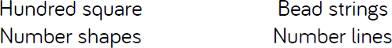

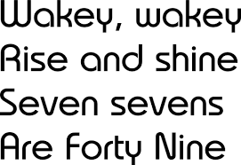
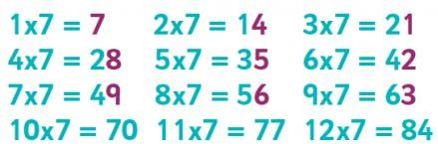
Pupils understand that the 7 times table is the hardest to learn because 7 is a prime number, and so the final digit does not repeat itself until 10 x 7.
However, when written in order in three columns, pupils spot that the ones digits are consecutive for every third multiplication fact. This occurs up until 10 x 7.
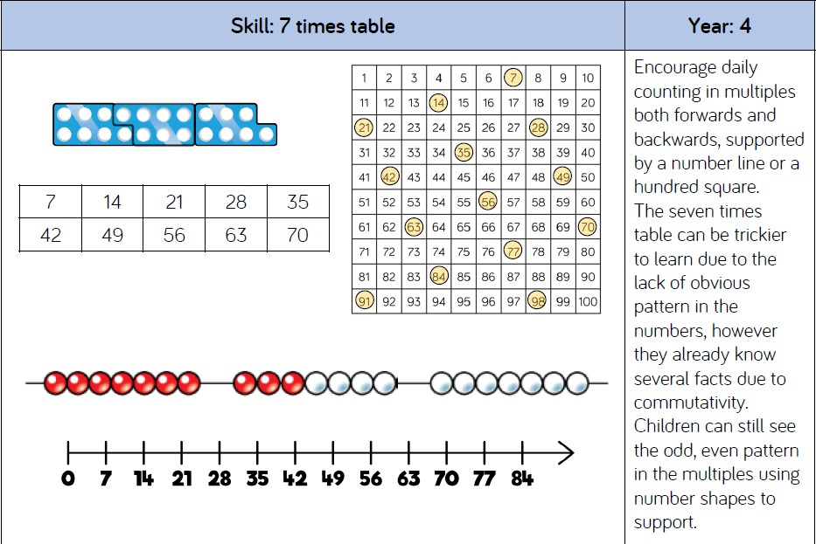

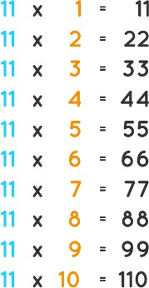
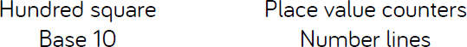
Pupils spot the symmetry of the 11 times table – at least up to 9 x 11.
When 11 is multiplied by any 1-digit number, the product of that number is written twice.
Pupils spot that when a 2-digit number is multiplied by 11, if the sum of the digits of the 2-digit number is placed between the digits of the two-digit number, it creates the answer. For example, 11 x 12: the sum of 1 and 2 = 3. 3 is placed between 1 and 2 to make 132.
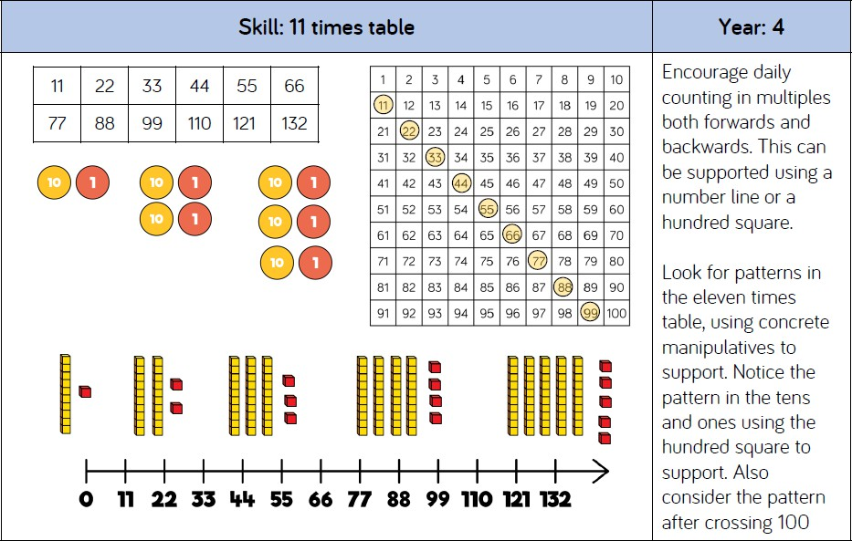

11 x | 11 | = 121
11 x | 12 | = 132

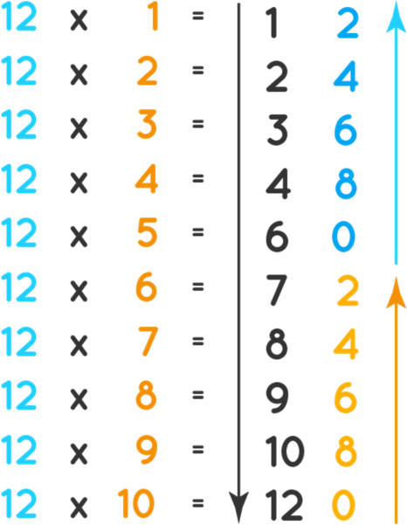
Pupils spot that there is a pattern for every five multiples of twelve: 12, 24, 36, 48, 60, 72, 84, 96, 108,
120. The last digit of these multiples always repeat, which means that pupils can remember these digits to help them with the 12 times table.
Pupils spot that the digits, which are in the ones column, are occurring in a sequence 2, 4, 6, 8, 0, which then repeat. While in the tens column, the digits are increasing from top to bottom, skipping the numbers 5 and 11.
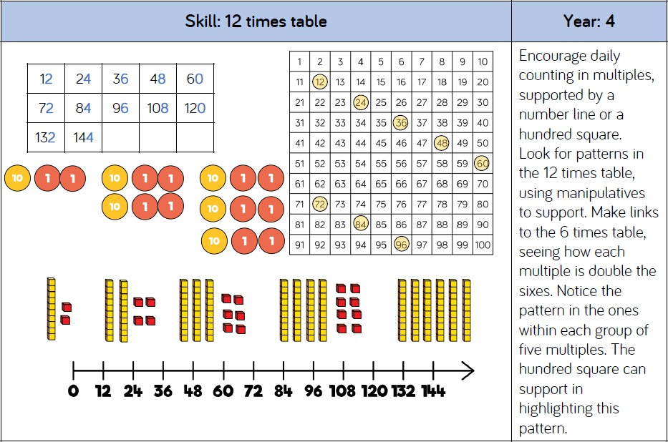

12 x 11
12 x 12
=
=
13 2
14 4

